Baiyue Electric
Digital Relay


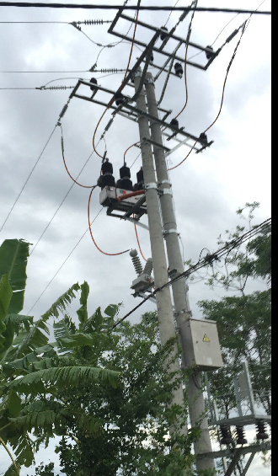
Installation manual VerSION 1.5
BC561

1 Start preparation
1.1 Important steps
To ensure trouble-free operation for many years, please read the following sections carefully to help and guide you during the entire installation of the new relay.


Before attempting to install or use the relay, it is necessary to carefully concern all warnings and cautions in this manual to avoid personal injury, equipment damage or downtime.
1.1.1 Note
Note: The BC561 operator should know that if the device is used out of the conditions specified in this manual, it may result in property damage, personal injury or even death, and must comply with the relevant regulations and instructions in the manual.
The following icons included in this manual represent safety-related status or other important information:
 Electrical warning icon: Indicates the risk of electric shock may occur.

Warning icon: Indicates that it may result in property damage, personal injury or even death.
 Information icon: to remind readers about the facts and conditions.
Early warning and warning may result in property damage, personal injury or even death, and must be clear; therefore, all warning and warning instructions must be strictly observed.
Early warning: The backside terminals of BC561 intelligent protection monitoring and control system may have dangerous voltage, even after disconnecting the auxiliary power within a few seconds it may also exist. When used, the grounding bolts on the backplane enclosure of BC561 intelligent protection and control system must be well grounded.
WARNING: The BC561 intelligent protection and monitoring device contains static-sensitive devices. When opening the case, wear a good ESD preventive wrist strap and avoid unnecessary contact with the device.
WARNING: To prevent electric shock, it must disconnect the device from the power input before opening the enclosure.
WARNING: The BC561 is not allowed to lay in the places where there has water vapor access, large temperature change, long time heavy vibration, or full of dust powder, flammable, explosive or corrosive gases.
Information: If the seal is broken, the warranty will be expired immediately, we can't ensure this device can work normally again, BAIYUE ELECTRIC reserves the right of final interpretation.

1.2 Open the packing and check
Open the BC561 unit's box and check if it is actually damaged or missing items.
Check the label on the side of the BC561 and see if the model of the relay is consistent with the order model.
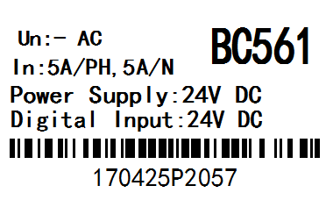
Figure 1-1. Identify the label
Please confirm receipt of the following items issued by BC561:
- Four studs that used to fix the BC561 unit into the panel.
- Factory test report

Please contact BAIYUE ELECTRIC for update of product information, the operating instructions and the latest software.

Information: If you find any actual damage to the BC561 unit, or if the listed content is incomplete, please contact BAIYUE ELECTRIC as soon as possible.
The information provided here does not include all the details of the changes described in the equipment, nor is it where the installation, operation and maintenance may be taken into account.
Please contact BAIYUE ELECTRIC for more information if the user has difficult problems that can not be solved by the instructions specified herein.

1.3 Safety instructions
The BC561 with enclosure grounding bolt shown in Figure 1-2 must be properly grounded.

Figure 1-2 The position of the grounding bolt
Before using the front USB port to communicate with the BC561, make sure that the computer is grounded.
If you are using a laptop, do not connect it to the power supply. The reason is that the cable used for the power supply or connector may not be properly grounded.
The reason for this is: not only to protect the staff, but also to avoid the existence of the voltage difference between the relay serial port and the computer port. Because the voltage difference may cause the computer or the relay to be permanently damaged.
In the event of failure to comply with safety regulations, BAIYUE ELECTRIC shall not be liable for damage of the BC561 unit, equipment or personnel injury.

1.4 Description
1.4.1 Introduction of system
With the increasing capacity of the power system, the scope of more and more wide, only the system components of the relay protection device, far from the full power system to prevent long-term large-scale power outage serious accident. In this regard, it is necessary to proceed from the overall situation of the power system to study the failure of the corresponding components after the action of the relay protection device, the system will show what conditions, the system will lose stability when what features, how to resume normal operation as soon as possible.
The task of system protection is when the normal operation of large power system is destroyed, as far as possible to limit the scope of its impact to a minimum, load power outage to a minimum.
The protection, control and measurement functions are initially performed by electromechanical components, then done by static components, finally by digital equipment. The digital device integrates all of these functions into a single device, known as an intelligent electronic device (IED). These IEDs must not only perform all the functions related to protection and control, but also communicate quickly, share information with each other, and send this information to the control dispatch center, which can lessen the usage of components and wiring by up to 70 %.
The BC561 is just one of these new generation devices and can be easily used with substation automation systems.

1.4.2 Hardware
The BC561 performs protection and control functions with a series of interconnect modules. First, it includes a set of AC transformers to detect current and voltage. These amplitudes are digitized and sent to a digital signal processor (DSP). BC561 is a digital relay, its CPU can control a variety of input / output signals.
Virtual input |  | Protection element  Logic |  | Virtual output
Contact input
 |  |  |  | Contact output
Analog input
Voltage and current
Theory illustration of BC561
Contact input / output: the signals from actual input / output contacts of relay
Analog input: input signal come from the current and voltage transformer, used to monitor the power system signal.
Logic: logic controller. It is a control module that performs a unit configuration (input / output value) and implements a logic circuit.
Protection components: Relay protection components, such as over-current, over-voltage, undercurrent, under-voltage, low-frequency, over-frequency protection.

1.4.3 Software
BC561 through the BP-PLP software can monitor data in real time, display phase angle vector illustration, display status, display SOE events and fault wave, user-friendly at the factory or in the field device settings, debugging and modification work.
The communication interface (USB, Ethernet) in the front of the panel and backside can be used to communicate with the BP-PLP software.

1.4.4 Communication
The processor performs detection, protection, control and communication functions. It uses a dedicated serial port to communicate with the HMI. Serial connection has a strong resistance to electromagnetic interference. Thus enhancing the security of the system.
BC561 has a USB serial port in front of panel, followed by another two communication modules.
A module provides asynchronous serial communication function, using the RS485 physical media. An RS485 physical channel can be connected up to 32 nodes, each node of the RS485-connected in the same line, RS485 + even in the twisted with another line, SHIELD for the common reference grounding, the same bus on the The SHIELD of the unit must be connected and grounded well.
Another module for Ethernet communication, using 10base-T physical layer standard, RJ45 connector. You can select the dual Ethernet simultaneous operating mode, see order number.BC561 is equipped with a standard interface: this USB interface located on the front panel,One or two Ethernet interfaces on the backplane is optional, one RS-485 interface on the backplane.Communication protocol: IEC60870-5-101/104, Modbus RTU, Modbus TCP / IP, DNP3.0 protocols, different communication port can be set to different specifications, you can run them at the same time.

1.5 BP-PLP software
1.5.1 System requirements
The BP-PLP software interface is the preferred means of editing settings and viewing actual values. Because the PC monitor can display more contents by a simple, compressible format.
To operate the PC correctly, the following minimum requirements for the BP-PLP software must be met:
• Pentium® or higher processor (Pentium® II 300 MHz or higher)
• Windows® NT 4.0 (Service Pack 3 or higher), Windows® 2000, Windows® XP
• Internet Explorer® 5.0 or higher
• 64 MB of RAM (128 MB recommended)
• 40MB of available system drive space and 40MB of available installation drive space
• USB serial and Ethernet ports for communication with BC561.
• Install the USB driver software (CH340SER.EXE)
• GPS time card (option)
• 1024 * 768 and above resolution displays

1.5.2 Installation
Copy the folder with the BP-PLP package to your computer.

1.5.3 Configure the USB connection
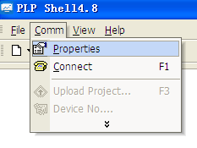
Before starting, make sure that the USB serial cable is properly connected to the USB port on the front panel of the BC561 unit.
① open the package "PLP" package and start "PLP.exe"
② Click the "Communication" option in the toolbar and select "Settings" to bring up the "Communication Settings" dialog box.
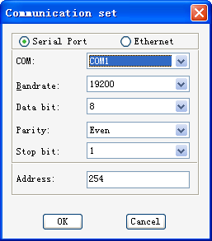
③ BC561 device and "PLP" software communication in two ways, one for the front panel USB serial communication, one for the back of the Ethernet port communication.
Click the "Use Serial Port" option and set the relevant parameters.
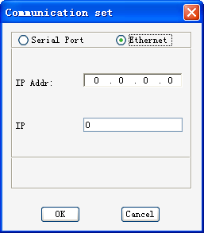
"Serial number" is selected according to the computer, "19200", "data bits" select "8", "parity" select "even parity", "stop bit" select " 1 "," Device Address "fill in" 254 ", set the parameters and click" OK ".
④ Click the "Connect" icon to complete the connection between the BC561 SETUP software and the BC561 device.
1.5.4 Configure the connection of Ethernet
Before starting, make sure that the Ethernet cable is properly connected to the Ethernet port on the back of the device.
The connection between the Ethernet and the device has same procedure as the connection between the USB and the device, click the "Use Ethernet" option when communicating. And set the relevant parameters, and then click the connection icon to finish the connection.

1.6 Order code
 | BC5 | X | * | X | X | * | * | H | 1 | * | * | * | *
Name | BC5 |  | | |  |  | | | | | | | | | | | | | | | | | BC561 Automatic reclosing controller
Application |  |  | 61 |  |  | | | | | | | | | | | | | | | | | Protect feeder
Phase current |  |  |  |  |  | 1 | | | | | | | | | | | | | | | 1A CT
 |  |  |  |  |  | 5 | | | | | | | | | | | | | | | 5A CT
Earthing current |  |  |  |  |  |  | S | | | | | | | | | | | | | 0.2A CT
 |  |  |  |  |  |  | 1 | | | | | | | | | | | | | 1A CT
 |  |  |  |  |  |  | 5 | | | | | | | | | | | | | 5A CT
Power |  |  |  |  |  |  |  | H | | | | | | | | | | | 110/220V DC or 220V AC or DC24V
Communication |  |  |  |  |  |  |  |  |  |  | D | | | | | RS485 : Modbus RTU, IEC60870-5-101 or DNP3.0
 |  |  |  |  |  |  |  |  |  |  | E | | | | | 10/100M RJ45 : Modbus TCP IEC60870-5-104 or DNP3.0
Language |  |  |  |  |  |  |  |  |  |  |  |  | E | English interface
 |  |  |  |  |  |  |  |  |  |  |  |  | C | Chinese interface

2 Product description
2.1 Summary
The BC561 intelligent protection and control system integrates protection, control, monitoring, measurement and recording. It adopts large capacity, resource redundancy design and plug-in structure. It is suitable for protection, control, measurement and monitoring of various voltage level power systems, Can be configured for a variety of distribution recloser or Sectionalizer controller and other special protection. Users can choose according to the needs of the scene, apply different models, applied to different objects. They can be used for different main wiring methods, such as single bus, double bus and multi-bus wiring. The protection function also supports different types of power grids, such as a neutral point suspension system, an arc suppression coil grounding system and a small resistance grounding system. In addition, BC561 can store four sets of protection settings, group switching function to quickly and easily adapt to a variety of operating methods. Time synchronization, event reporting, waveform capture, reduced troubleshooting time, and reduced maintenance costs. BC561 supports RS485 bus and Ethernet communication network form, to meet the different users, different industrial sites, different network environments, different sizes of systems on the communication and network structure requirements. And support dual-network mode, parallel or hot standby mode. Thereby further improving the reliability of the communication. You can use Modbus RTU, Modbus TCP, DNP3.0, IEC60870-5-101/104 protocol to achieve communication with the upper equipment.

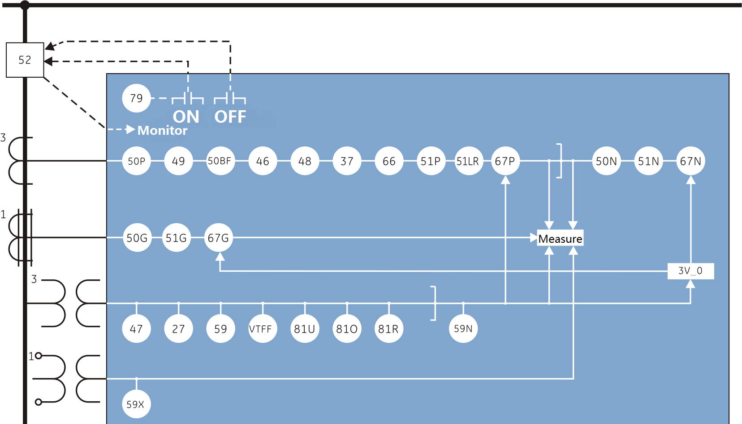
Figure 2.1 BC561 Functional block diagram
2.2 BC561 function at a glance
2.2.1 ANSI code and protection functions
ANSI code | Features |  | ANSI code | Features
27 | Phase undervoltage |  | 59N | Zero sequence overvoltage
27X | Auxiliary circuit undervoltage |  | 59X | Auxiliary circuit overvoltage
37 | Undercurrent |  | 66 | Maximum number of starts
46 | Negative sequence overcurrent |  | 67P | Phase direction overcurrent
47 | Negative sequence overvoltage |  | 67N | Zero sequence direction overcurrent
48 | Start too long |  | 67G | Grounding direction overcurrent
49 | Thermal overload |  | 79 | Three-phase reclosing
50P1 | Definite time overcurrent I stage |  | 81U | Low frequency
50P2 | Definite time overcurrent II stage |  | 81O | over frequency
50P3 | Definite time overcurrent |  | 81R | Frequency change rate (slip)
50N | Zero sequence overcurrent |  | VTFF | VT line disconnected
50G | Grounding overcurrent |  |  | Trip loop monitoring
50BF | Circuit breaker failure |  |  | Rewound overcurrent
51P | Inverse time limit overcurrent |  |  | Circuit breaker remote control division
51N | Zero sequence Inverse time limit overcurrent |  |  | Non-power protection | Light gas warning
51G | Grounding reverse time limit overcurrent |  |  | Non-power protection | Heavy gas tripping
51LR | Stall protection//Locked Rotor |  |  | Non-power protection | Pressure release
59 | Phase overvoltage |  |  | Non-power protection | Temperature protection

BC561 (Recloser) function:
ANSI code | Features |  | ANSI code | Features
27 | Phase undervoltage |  | 51N | Zero sequence Inverse time limit overcurrent
46 | Negative sequence overcurrent |  | 51G | Grounding reverse time overcurrent
50P1 | Definite time overcurrent I stage |  | 59X | Auxiliary circuit overvoltage
50P2 | Definite time overcurrent II stage |  | 81U | Low frequency
50P3 | Definite time overcurrent III stage |  | 79 | Three-phase reclosing
50N | Zero sequence overcurrent |  |  | Trip loop monitoring
50G | Grounding overcurrent |  | VTFF | VT line disconnected
50BF | Circuit breaker failure |  |  | Sensitive Grounding overcurrent
51P | Inverse time limit overcurrent |  |  | Reclosing conditions
BC561-II (LBS controller) function：
ANSI code | Features |  | ANSI code | Features
27 | Phase undervoltage |  | 51N | Zero sequence Inverse time limit overcurrent
81U | Low frequency |  | 51G | Grounding reverse time overcurrent
50N | Zero sequence overcurrent |  | 59X | Auxiliary circuit overvoltage
50G | Grounding overcurrent |  |  | Trip loop monitoring
50BF | Circuit breaker failure |  | VTFF | VT line disconnected
51P | Inverse time limit overcurrent |  |  | Sensitive Grounding overcurrent
 | SF6 LOW/ALARM
 | Manual lock

2.2.2 Other functions
Input / output: 8 loops AC current, 4 loops AC voltage input; up to 16 contact inputs, 8 contact outputs (one of which is device fault signal).
Measurement: including three-phase (line) voltage, zero sequence voltage, voltage average, three-phase current, zero sequence current, current average, three-phase power factor, average power factor, frequency, two-way active power, and reactive power;
Communication: front panel USB interface, backside RS485 interface, back Ethernet interface, a variety of communication protocols: Modbus TCP / IP, Modbus RTU, IEC60870-5-101/104, DNP3.0;
Monitoring: event recording 100 events; high-resolution recording, can sample 28 cycles of data / bar, sampling rate of 32 / week; 8 LED lights; can be configured value, the parameters of the human-machine interface; LCD liquid crystal display.
Other: clock synchronization; BP-PLP software; multi-rating group (4 sets of settings).
2.3 Technical specifications
2.3.1 Protection elements
Protection
2.3.1.1 Phase undervoltage（27）
Voltage: Phase-to-phase voltage of the fundamental phase (no harmonics)
Start value: 10 ~ 120V, step 0.1V
Reset value: 102% ~ 103% start value
Accuracy: ± 3% of reading value
Action time: 0 ~ 99s, step 0.01s
Delay accuracy: ± 3% action time or ± 35mS (take a large value)
2.3.1.2 Auxiliary circuit undervoltage（27X）
Start value: 10 ~ 120V, step 0.1V
Reset value: 102% ~ 103% start value
Accuracy: ± 3% of reading value
Action time: 0 ~ 99s, step 0.01s
Delay accuracy: ± 3% action time or ± 35mS (take a large value)
2.3.1.3 Undercurrent（37）
Current: fundamental phase (no harmonics)
Start value: 0.1 ~ 19CT, step 0.01CT
Reset value: 102% ~ 103% start value
Accuracy: ± 3% of reading value ± 10mA from 0.1 to 0.5CT and ± 3% of reading value at 0.5CT
Action time: 0 ~ 99s, step 0.01s
Delay accuracy: ± 3% action time or ± 35mS (take a large value)
2.3.1.4 Negative sequence overcurrent（46）
Current: fundamental phase (no harmonics)
Start value: 0.1 ~ 19CT, step 0.01CT
Reset value: 97% ~ 98% start value
Accuracy: ± 3% of reading value ± 10mA from 0.1 to 0.5CT and ± 3% of reading value at 0.5CT
Action time: 0 ~ 99s, step 0.01s
Delay accuracy: ± 3% action time or ± 35mS (take a large value)

2.3.1.5 Negative sequence overvoltage（47）
Start value: 10 ~ 120V, step 0.1V
Reset value: 97% ~ 98% start value
Accuracy: ± 3% of reading value
Action time: 0 ~ 99s, step 0.01s
Delay accuracy: ± 3% action time or ± 35mS (take a large value)

2.3.1.6 Definite time limit overcurrent I/II/III stage（50P1/50P2/50P3）
Current: fundamental phase (no harmonics)
Direction: positive / reverse direction optional
Start value: 0.1 ~ 19CT, step 0.01CT
Reset value: 97% ~ 98% start value
Accuracy: ± 3% of reading value ± 10mA from 0.1 to 0.5CT and ± 3% of reading value at 0.5CT
Action time: 0 ~ 99s, step 0.01s
Delay accuracy: ± 3% action time or ± 35mS (take a large value)

2.3.1.7 Zero sequence overcurrent（50N）
Current: fundamental phase (no harmonics)
Direction: positive / reverse direction optional
Start value: 0.1 ~ 19CT, step 0.01CT
Reset value: 97% ~ 98% start value
Accuracy: ± 3% of reading value ± 10mA from 0.1 to 0.5CT and ± 3% of reading value at 0.5CT
Action time: 0 ~ 99s, step 0.01s
Delay accuracy: ± 3% action time or ± 35mS (take a large value)

2.3.1.8 Grounding overcurrent（50G）
Current: fundamental phasor (no harmonics)
Start value: 0.1 ~ 19CT, step 0.01CT
Reset value: 97% to 98% start value
Accuracy: ± 3% of reading value ± 10mA from 0.1 to 0.5CT and ± 3% of reading value at 0.5CT
Action time: 0 ~ 99s, step 0.01s
Delay accuracy: ± 3% of the action time or ± 35mS (take a large value)

2.3.1.9 Inverse time limit overcurrent (51P)
Current: fundamental phasor (no harmonics)
Start value: 0.1 ~ 19CT, step 0.01CT
Reset value: 97% to 98% start value
Action curve: general / strong / super / long reverse time limit
Inverse time limit constant: 0 ~ 1, step 0.01
Accuracy: ± 5% of the action time or ± 40ms (take a large value)

2.3.1.10 Zero sequence Inverse time limit overcurrent (51N)
Current: fundamental phasor (no harmonics)
Start value: 0.1 ~ 19CT, step 0.01CT
Reset value: 97% to 98% start value
Action curve: general / strong / super / long anti-time limit
Inverse time: 0 ~ 99s, the difference between 0.01s
Accuracy: ± 5% of the action time or ± 40mS (take a large value)

2.3.1.11 Grounding Reverse Time Overcurrent (51G)
Current: fundamental phasor (no harmonics)
Start value: 0.1 ~ 19CT, step 0.01CT
Reset value: 97% to 98% start value
Action curve: general / strong / super / long anti-time limit
Inverse time: 0 ~ 99s, the difference between 0.01s
Accuracy: ± 5% of the action time or ± 40mS (take a large value)

2.3.1.12 Phase overvoltage (59)
Voltage: phase-to-phase voltage of the fundamental phase (no harmonics)
Start value: 10 ~ 120V, step 0.1V
Reset value: 97% to 98% start value
Accuracy: ± 3% of reading value
Action time: 0 ~ 99s, step 0.01s
Delay accuracy: ± 3% of the action time or ± 35mS (take a large value)

2.3.1.13 Zero sequence overvoltage (59N)
Start value: 10 ~ 120V, step 0.1V
Reset value: 97% to 98% start value
Accuracy: ± 3% of reading value
Action time: 0 ~ 99s, step 0.01s
Delay accuracy: ± 3% of the action time or ± 35mS (take a large value)

2.3.1.14 Phase direction overcurrent (67P)
ABC phase sequence: phase A (VBC), phase B (VCA), phase C (VAB)
ACB phase sequence: phase A (VCB), phase B (VAC), phase C (VBA)
Polarization Current: Three Phase Line Current
Polarization voltage threshold: 10 ~ 120V, step 0.1V
Characteristic angle: -45 ° ~ 135 °
Directionality: forward and reverse can be selected by setting
Angle accuracy: ± 1 ° when I> 0.5A, V> 20Vac
Response time: <30ms

2.3.1.15 Zero sequence direction overcurrent (67N)
Polarization: voltage (zero sequence), current (zero sequence)
Polarization voltage threshold: 10 ~ 120V, step 0.1V
Characteristic angle: -135 ° ~ 45 °
Directionality: forward and reverse can be selected by setting
Angle accuracy: ± 1 ° when I> 0.5A, V> 20Vac
Response time: <30ms

2.3.1.16 Grounding Direction Overcurrent (67G)
Polarization: voltage (Uch4), current (I01)
Polarization voltage threshold: 10 ~ 120V, step 0.1V
Characteristic angle: 0 ° ~ 180 °
Directionality: forward and reverse can be selected by setting
Angle accuracy: ± 1 ° when I> 0.5A, V> 20Vac
Response time: <30ms

2.3.1.17 Over frequency (81O)
Start value: 45.5 ~ 55Hz(50Hz)/ 55 ~ 65Hz(60Hz), step difference 0.01Hz
Note：The 60Hz products need to be specially mentioned when ordering.
Reset value: ± 0.1Hz for start value
Accuracy: ± 0.01Hz
Action time: 0 ~ 99s, step 0.01s
Delay accuracy: ± 3% action time or ± 35ms (take a large value)

2.3.1.18 Frequency change rate (low frequency) (81R / 81U)
Slip lock start value: 1Hz / s ~ 10Hz / s, step 0.1Hz / s
Low frequency start value: 45.5 ~ 55Hz, step 0.01Hz
Reset value: ± 0.1Hz for start value
Accuracy: ± 0.01Hz
Action time: 0 ~ 99s, step 0.01s
Delay accuracy: ± 5% action time or ± 50ms (take a large value)

2.3.1.19 Circuit Breaker Failure (50BF)
Current: fundamental phasor (no harmonics)
Monitoring start value: 0.1 ~ 19CT, step 0.01A
Reset value: 97% to 98% start value
Accuracy: ± 3% for ± 0.1% for 0.1 to 0.5 CT and ± 3% for> 0.5CT
Delay accuracy: ± 3% of the action time or ± 35mS (take a large value)

2.3.1.20 Three-phase reclosing (79)
Program: three-phase trip program
Closing times: 1 reclosing can be made before locking
The whole group reset time: 0 ~ 99s, grade difference 0.01s
Charging time: 0 ~ 99s, grade difference 0.01s
Allowed condition: Optional by setting
Action time: 0 ~ 99s, step 0.01s
Delay accuracy: ± 3% of the action time or ± 35mS (take a large value)

2.3.1.21 VT line disconnection (VTFF)
The algorithm is based on negative sequence voltage and low voltage determination or with current, without voltage

2.3.2 Measurement and measurement accuracy
Protection current: ± 1%
Measuring current: ± 0.5%
Voltage: ± 0.5%
Phase angle: ± 1 °
Power factor: ± 0.5%
Frequency: ± 0.01Hz
Power: ± 0.5%
Active power: ± 0.5%
Reactive power: ± 0.5%
2.3.3 Monitor
2.3.3.1 Transient events
Capacity: 100 scrolling events
Resolution: 1ms
Trigger: Digital input input state change, protection element trigger, device power on, self-test status change, value change
Save: Save in nonvolatile memory

2.3.3.2 Recording waves
Record: 8 records
Sampling: 32 points / week
Record length: 28 weeks / bar
Data: 5 current channels, 4 voltage channels, 112 status bits
Storage: Save in nonvolatile memory
Format: COMTRADE format

2.3.4 input
2.3.4.1 Current input
Measuring range: 0 ~ 99A
Power consumption: rated 5A, each phase is not greater than 0.5VA
Rated 1A, each phase is not greater than 0.2VA
Rated at 0.2A, not more than 0.1VA per phase
Overload capacity: 3 times the rated current, continuous work
20 times the rated current for 4s
50 times the rated current for 1s

2.3.4.2 Contact input input
Voltage threshold: 18 ~ 36VDC
Impedance:> 100KΩ
Debounce time: 1 ~ 99ms, step 1ms

2.3.4.3 Voltage input
Measuring range: 0 ~ 120V
Power consumption: rated at 100V when each phase is not greater than 0.3VA
Overload capacity: 1.4 times the rated value, continuous work

2.3.5 Output
DO1-7
Continuous bearing: 5A
Breaking capacity: DC, inductive load, L / R = 40ms, 220V / 0.5A

2.3.6 Control power supply
Rating: 220VDC / AC or 110 VDC / AC
Range: 176-256 VDC, 160-240 VAC @ 50 Hz
Power consumption: normal work less than 10W, action is not greater than 15W
Loss of pressure to maintain time: 220VAC / DC 100ms, no device reset

2.3.7 communication
2.3.7.1 USB port
Version: 2.0
Agreement: manufacturer agreement

2.3.7.2 RS485
Rate: 1200-38400bps
Default rate: 9600bps
Protocol: Modbus RTU, IEC60870-5-101 or DNP3.0

2.3.7.3 Ethernet port
Mode: 10 / 100M (adaptive)
Interface: RJ45
Protocol: Modbus TCP / IP,DNP3.0 or IEC60870-5-104

2.3.8 Type test
Dielectric strength: GB / T14598.3-2006（IEC60255-5-2000）: 2000VAC
Insulation resistance: GB / T14598.3-2006（IEC60255-5-2000）:> 100MΩ
Impulse voltage: GB / T14598.3-2006（IEC60255-5-2000）: 4KV
Vibration test: GB / T11287-2000（IEC 255-21-1-1988）: Level 1
Impact and Collision: GB / T14537-1993（IEC 255-21-2-1988）: Level 1
Oscillation wave immunity: GB / T14598.13-2008（IEC 60255-26:2013）: Level 3, 1MHz, 2.5KV / 1KV
Electrostatic discharge: GB / T14598.14-1998（IEC 60255-22-2:2008）: 4, ± 8KV contact / ± 15kv air
Radiation Electromagnetic Field: GB / T14598.9-2002（IEC 60255-22-3:2000）: Level 3, 10V / m
Fast transient: GB / T14598.10-2007（IEC 60255-22-4:2008）: Class A, ± 4KV / 2.5KHz and 5KHz
Surge immunity: GB / T 14598.18-2007（IEC 60255-22-5:2002）: Level 3, ± 2KV / ± 1KV, 1 time / min
Radio frequency immunity: GB / T 14598.17-2005（IEC 60255-22-6:2001）: Class 3, 10V
Radiation emission limit: GB / T 14598.16-2002（IEC 60255-25:2000）: range 30MHz ~ 1000MHz, ranging 3m, step 5KHz, 1ms, bandwidth 120KHz
Conducted emission limits: GB / T 14598.16-2002（IEC 60255-25:2000）: range 150KHz ~ 30MHz, step 5KHz, 20ms,IF bandwidth 9KHz

2.3.9 Mechanical properties
Enclosure: Metal shell,
170 × 252× 168mm (width × height × depth),
Weight: Net weight of about 3.55KGs, transport weight of about 4.3KGs

2.3.10 Environmental conditions
Operating temperature: -20 ℃ ~ +60 ℃
Storage temperature: -40 ℃ ~ +80 ℃
Humidity: 90% non-condensing
Type test report may be provided if required by the customer.

3 BC561 installation
3.1 Mechanical installation
3.1.1 BC561 product size
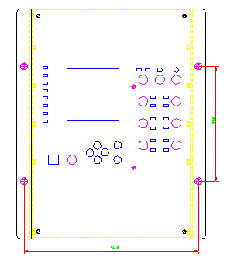
Figure 3.1 BC561 outline structure
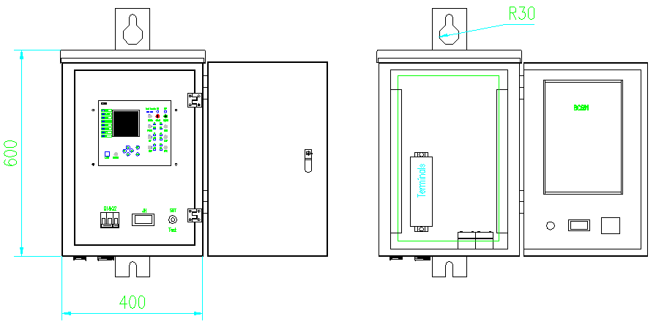
Control box with BC561 installed

3.1.2 installation method
First, according to the hole shown in Figure 3.1, in the cabinet panel cut the shadow part of the hole.
Step 1: The BC561 device is introduced from the front into the open hole,
Step 2: Open the flip tab at both ends of the device and insert the four mounting screws that are carried in the mounting hole.
Step three: tighten the attached mounting nut, the intensity can be appropriate. Installed BC561 around to leave some space in order to facilitate heat, handling, wiring and operation.

3.2 Front panel
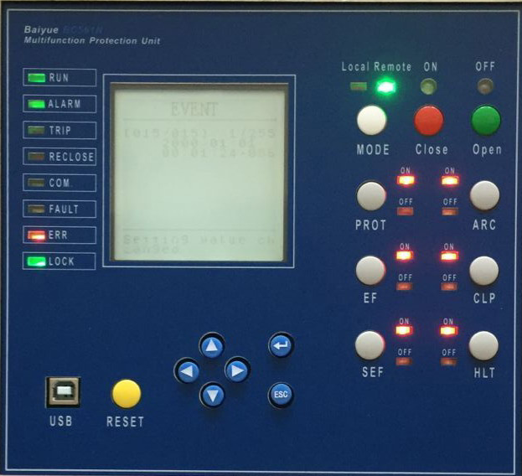
Figure 3.2 BC561 device front panel
BC561 front panel totally including:
• 7 keys,9 Shortcut key
• 1 USB interface,
• 8 LED indicators,
• A 128 × 128 LCD monitor.
BC561 settings in the panel, the user through the operation of the button on the device settings, parameters and other data settings, the device can observe through the liquid crystal display and LED lights. It can also be used with the data cable connected with the computer, monitor data in real time through the matching BP-PLP software, display phase angle vector, display status, display SOE events and fault wave recorder, user-friendly device in the field settings, debugging and modify the work.

3.2.1 LCD display
BC561 uses a liquid crystal display, which uses 128 * 128 dot matrix, you can display a lot of information, such as:
• One-line diagram, including switch and span, real-time position;
• Measure current, voltage, power and other real-time values, current, voltage real-time waveform;
• Device version, serial number, self-test, and so on
• Sequence Of Event (SOE)
• Various device parameters
• Various setting parameters
• Time
3.2.2 LED indication
The BC561 device has eight LED indicators that can be used to indicate the operating status of the device, protection action information, device alarms, communication status, and associated various Boolean variables
Indicator light | Colour | annotation
LED1～LED8 | red light | Instructions for device protection actions or alarms

Table 3.1 BC561 indicator definition

Information: The indicators listed in Table 3.1 are defined as the initial definition at the factory. The actual indicator light will be slightly different from the device model. Please use it as a physical object and can also be customized according to the user's requirements.
3.2.3 Button
There are 7 buttons on the BC561 panel, and their functions are shown in the table below (Table 3.2).
Figure 3.2 BC561 front panel key definition table
key | icon | description
"Up" / "Down" key |  | Move the cursor up or down or increase or decrease the value
"Left" / "Right" key |  | Left and right to move the cursor or switch between the main screen
Enter |  | Go to the next level menu or follow the screen prompts
Escape key |  | Return to the previous menu or follow the screen prompts
Reset key |  | Reset signal indicator and signal relays
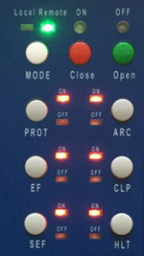
MODE：Remote/local key
CLOSE：Closing key
TRIP：Opening key
PROT： Protection key
EF： Earthing fault key
SEF： Sensitive earthing fault key
ARC： Auto reclose control key
CLP： Cold load pickup
HLT：Hot line tag
3.3 Backplane terminal description
The backside terminal block of BC561 is defined as shown below
With Ethernet, RS485
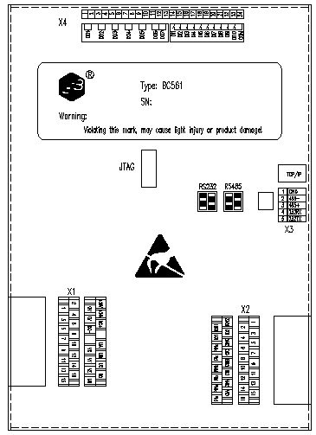
Terminal definition:
Terminal group X1 is analog AC voltage input terminal, power supply terminal;
Terminal group X2 is analog AC current;
Terminal group X3 is RS-485 interface;
Terminal group X4 for the connection input and output terminal;
1 Ethernet port, 1 RS-485 communication.3.4 Electrical wiring
3.4.1 AC current, voltage wiring
The double row terminal x1 of BC561 backside is used for AC connection terminal that allows cable with a maximum diameter of 6 mm². total 8 pairs terminals connected with CT, connected to PT, no common terminal, to facilitate the external wiring.
Information: The protection grounding connected to the BC561 backplane communication terminal X1 should be grounded at the installation of the BC561 unit, rather than grounding at the installation of the CT or PT. Also, the BC561 installation must have a good grounding system.
Warning: The PCB parts inside BC561 are mostly static-sensitive devices, open the enclosure must wear a good grounding anti-static gloves.
The BC561 can support five basic AC wire connections, as shown in Table 3.3.
Among them: the way 1, 4 for the incoming line, feeder, distribution transformer, motor, transformer backup protection and control,
Mode 2 and Mode 3 are suitable for the protection of capacitors,
Mode 5 applies to the bus section of the standby power supply.
Ia, Ib, Ic for the protection phase current,
IA, IB, IC for the measurement phase current, can be connected A, B, C three-phase, but also only A, C two-phase.
I01 in the Mode 1 to 4 can be connected to the zero sequence current, unbalanced current, etc., in the Mode 5 access line into the measured current IL1 as the line with or without current criteria.
Us is the opposite side of the line voltage (reclosing check pressure, check the same period), can be taken from Ua or Uab, the secondary rating of 100V or 100 / V. 3U0 for the zero sequence voltage, the Mode 1, 2, 3U0 obtained by calculation, Ud for the capacitor group differential pressure.
Uch1 and Uch2 are connected to the voltage Uab and Ubc, respectively, through the calculation can be Uca, U1, U2, but not zero sequence voltage 3U0, Ua, Ub, Uc. Therefore, the calculation of the power element in this mode using two component method.
BC561 support five kinds of AC voltage wiring:
Figure 3.3 BC561 device wiring method introduction table
Wiring | Voltage connection | Uch1—Uch3 aisle | Uch4 aisle | Applicable circuit
Mode 1 | Y type wiring | Ua, Ub, Uc | 3Uo | Line / feeder and so on
Mode 2 | Y type wiring | Ua, Ub, Uc | Ud | Capacitor
Mode 3 | Open triangular | Uch1 then Usb line voltage, Uch2 then Ubc line voltage, Uch3 then 3Uo (zero sequence voltage) | Ud | Capacitor
Mode 4 | Open triangular | Uch1 then Usb line voltage, Uch2 then Ubc line voltage, Uch3 then 3Uo (zero sequence voltage) | Us | Line / feeder and so on
Mode 5 | Split 2 bus voltage | UabUch1 then Uab, Uch2 then section of the Ubc, Uch3 then section of the Uab | Ubc Uch4 access  Part II of Ubc | Mother of self-cast
Us: for the reference voltage, can be connected to the line side voltage, or on the line Ua or Uab (reclosing check pressure, check the same period), or other AC voltage input input.
Ud: is the differential pressure of the capacitor (unbalanced voltage).
BC561 has 8 current input input, divided into 3-way protection current input input, 3-way measurement current input input and 2 Zero sequence current input.
Ia, Ib, Ic for the protection of current input input, IA, IB, IC for the measurement of current input input.ν
protection current and measurement current input input are Y-type wiring, 3CT way wiring A, B, C three-phase, 2CT way only A, C two-phase.ν
I01 can access zero sequence current, unbalanced current and so on. For standby mode, I01 can be connected to the two incoming line of the measured current as a line to determine whether the current.
Channel number | Channel name | the way1 | the way2 | the way3 | the way4 | the way5
1 | Ia | Ia | Ia | Ia | Ia | Ia
2 | Ib | Ib | Ib | Ib | Ib | Ib
3 | Ic | Ic | Ic | Ic | Ic | Ic
4 | I01 | IN1 | IN1 | IN1 | IN1 | IL1
5 | IA | IA | IA | IA | IA | IA
6 | IB | IB | IB | IB | IB | IB
7 | IC | IC | IC | IC | IC | IC
8 | Uch1 | Ua | Ua | Uab | Uab | Uab1
9 | Uch2 | Ub | Ub | Ubc | Ubc | Ubc1
10 | Uch3 | Uc | Uc | UN | UN | Uab2
11 | Uch4 | US | Ud | Ud | Us | Ubc2
Figure 3.4 BC561 device terminal group A wiring mode correspondence table
The polarity of exchange affects the correctness of direction protection, power components, sequence components, and simultaneous operation. Therefore, the field wiring must ensure that the polarity is correct. The angle of each AC (relative to Uch1 and Uch1 is required to be greater than 13V) can be observed in the debug man-machine interface of BC561 to verify the polarity of wiring. For access to zero sequence / unbalanced current or voltage, because the usual value is small, the angle is uncertain, can not directly estimate the angle, so take more phase verification. For example, A phase to get rid of, then into B phase and C phase vector sum, it is easy to verify the polarity of wiring. Therefore, you can use BC561 test, verify the field wiring phase sequence and polarity.
AC connection, protection current and measurement current are used in several components, Us selection, CT and PT ratio, the secondary side of ratings are set in system parameters. BC561 in accordance with different settings, automatically select the appropriate algorithm for compensation calibration.
When two currents are used for the protection current, the zero sequence current IN can not be calculated by calculation. The positive sequence current I1 and the negative sequence current I2 are calculated assuming that IN is equal to 0. Similarly, the power element is assumed to be equal to 0 under the premises.
When measuring current using two components, the calculation of P and Q is also based on the assumption that IN is equal to zero.
Uch1 and Uch2 are connected to the voltage Uab and Ubc, respectively, through calculation can be Uca, U1, U2, but not zero sequence voltage 3U0, Ua, Ub, Uc. Therefore, the calculation of the power element in this mode using two component method.

3.4.2 Power input wiring
BC561 backplane terminal block x4 for the power supply terminals, x4.3 and x4.4 for access to auxiliary power, non-polar, AC and DC can be, to the internal switching power supply. Built-in 3AT / 250V fuse and power filter, lead to the enclosure grounding bolts, but must ensure reliable grounding.

3.4.3 Contact input
The terminal strip x5 of the BC561 backplane is the terminal block of switching input, allowing the use of cable connections with a maximum wire diameter of 1.5 mm². As shown in the back terminal diagram, there are 10 input inputs on terminal strip D. All of the switching input of the BC561 is non-polar, allowing access to 18VDC ~ 36VDC, with the same group must have the same polarity, because they have one end connected to the same common。
Each group has its own "recording time" parameter, the range is 0 ~ 999ms, user can modify the scene.
BC561 for all the switching input of the changes are time sequence records (SOE), "recording time" for the start of anti-shake and anti-jamming, to prevent sending error SOE, and even lead to logical confusion, "recording time" Confirm the time of remote_command. When the change (unstable) time is less than the "recording time", the change process BC561 is not processed, and the state of the change is 5 times for 5 consecutive times after the "recording time" Only to be recognized. The recorded start-up displacement time is still the initial moment at which the displacement occurs, and the "recording time" is not added. Therefore, each group into the "recording time" must be set to the same group into the maximum possible jitter time, and leave a certain margin, such as 20 ℅. "Recording wave time" set a large number will not affect the record of the stability of the time, on the contrary set the small down will miss the record of the real displacement time. However, the "recording time" setting of the General Assembly on the delivery of SOE and logic processing to produce a corresponding delay.

3.4.4 Contact output
BC561 on the back of the x5 terminal strip has 7 control output, DO1 ~ DO7, where the seventh output for the device self-test outlet ALARM. BC561 factory "ALARM" for the normally closed contact output, for the device fault signal relay.
BC561 has three kinds of switching output methods: pulse, level and synchronization. Three ways to apply to different control objects and peripheral circuits, or different purposes. When the "pulse" type output is selected, the corresponding pulse width (0.01 ~ 2.55S) is also set. Each output has output mode and pulse width parameters, can only be set and view with BP-PLP, when the output register status is 1, the pulse output will drive the corresponding relay and maintain a certain time (pulse width), and then release the relay And clear the status of the output register. "Voltage Level/Potential" switching output is simple, at any time according to the status of the output register to drive (1) or release (when 0) the corresponding relay. The "sync" is similar to the "voltage level" output, except that only after the signal is reset or the device is reset, then it can clear the output register.

3.4.5 Communication wiring
3.4.5.1 USB wiring
Below the BC561 front panel is a square receptacle that is a standard USB square receptacle. Use the supplied USB cable to connect to the computer and connect to the device through the supplied "BP-PLP" software. Please refer to Section 1.5.3 for connection settings

3.4.5.2 RS485
There are two sets of RS485 communication channels, terminal numbers x3-4 and x3-5 are A1, B1, terminal numbers x3-9 and x3-10 are A2, B2, terminal number x3-1 x3-6 is "SHIELD" common reference To ground.
Use a shielded twisted pair for RS485 communication cable and connect the wires of A1 and B1 to each other. The "SHIELD" terminal is connected to another pair of twisted pairs. So, you can use at least 2 pairs of wires, each wire is 0.25, 0.34 or 0.5 mm² shielded twisted pair wiring. To prevent the grounding current from forming the circuit, the connected shield and "SHIELD" must be grounded only at one end, usually at the master station. Be careful to ensure a good connection to the shield at each communication node.

Figure 3.6 wiring diagram of RS485 of bc500n device
BC561

BC561

A/-
B/+
GND
RS485+
RS485-
SHIELD

BC561
RS485-
RS485+
SHIELD
RS485-
RS485+
SHIELD

1nF/100V 120Ω/0.25W 120Ω/0.25W 1nF/100V

A1and B1 signals can also be called RS485 - and +, SHIELD can also be called GND. An RS485 physical channel can hold up to 32 nodes. Each node's RS485- or A is connected to the same line. RS485 + or B is connected to another line with which the SHIELD or GND is connected. See Figure 3.6.
To reduce the traveling wave reflection, when the total length of an RS485 physical channel is greater than 100 meters, the communication rate is greater than 9600bits / s, we recommend adding a terminal matching circuit at both ends of the channel. The longer the length or the higher the communication rate, the more necessary. For the general shielded twisted pair, the terminal matching circuit can be a 120Ω / 0.25W resistor, it can be RC circuit, as shown in Figure 3.6. The latter effect is better, it is recommended to use. In addition, the wiring should pay attention to reduce the RS485 physical channel on the length of the branch line, it is recommended not more than 2 meters, as far as possible to the end of the connection, and all the wiring head to be welded firmly.
Information: Although the RS485 communication distance of up to 1km or more, but the actual situation is often fragile, especially through the outdoor communication line, long-term use is dangerous. Power failure caused by the potential difference or lightning, etc. can easily damage the equipment. So we do not recommend using more than 300 meters and through the outdoor RS485 channel. If necessary, it is recommended to use fiber converter to do relay.
BC561 device RS485 port communication parameters are communication address, rate. The communication address is shared by all the communication ports of the device backplane. It can be used for the communication protocol to address the device. It can be set from 1 to 254. RS485 port rate can be set to a range of 1200 ~ 38400bits / s. BC561 device RS485 port support communication protocol IEC60870-5-101 and Modbus RTU, can be installed in the device panel man-machine interface or through the matching "BP-PLP" software settings.

3.4.5.3 Ethernet wiring
BC561 backplane Ethernet for the Ethernet interface, using 10base-T physical layer standard, RJ45 connector. BC561 RJ45 using 10base-T standard definition shown in Figure 3.7.
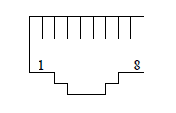
PIN SIGNAL
Figure 3.7 Ethernet RJ45 pin definition
1 Tx+
2 Tx-
3 Rx+
6 Rx-

According to the IEEE 802.3i standard, 10base-T Ethernet can be wired with Category 3 and above unshielded twisted pair, ie UTP cable. It has 4 pairs of twisted pair, the first butt RJ45 1 and 2 pins, the second butt 3 and 6 pins. 10base-T site between the maximum distance of 100 meters or less, even the relay, 10base-T LAN maximum diameter of not more than 500 meters.
Above refers to the maximum wiring distance in the office environment, in the interference of serious industrial site, in order to ensure smooth communication, UTP cable should be shortened to the wiring distance.
If Ethernet is selected according to the order number, its corresponding IP address can be defined by the user through the matching "BP-PLP" software or the key operation on the front panel of the device. The BC561 Ethernet port adopts the Modbus TCP / IP protocol.

3.4.6 Shield terminal
The SHIELD terminal is the common reference for the B terminal strip, which is the common reference grounding for RS485 and RS232. In RS485 and RS232 integrated wiring system, to ensure that each BC561 SHIELD terminal a good grounding, that is, each BC561 SHIELD terminal only one way to the grounding grid. And, all the wiring is RS485 or RS232 bus connected together BC561, the SHIELD terminal must also be connected. In addition, the equipment connected to the RS485 or RS232 bus of the BC561 must be on the same grounding grid.
The terminal bar X3 is defined as follows:
X3 Terminal | definition
1 | SHIELD
2 | RX
3 | TX
4 | RS485-
5 | RS485+
Figure 3.5 Terminal X3 defines the table
3.4.7 Grounding wiring
The BC561 backplane has a housing grounding bolt, identified as .
Must be a good grounding of the bolt, and the use of stainless steel joints, grounding wire cross-section to be greater than 2.5mm ², close to the ground bus.

4 Interface operation
4.1 Text menu navigation
BC561 all types of protection devices have a text menu, which is through the man-machine interface to achieve value, measurement, change settings such as a visual menu. Press the "Left" or "Right" key in the main menu interface to switch between the monitor screen and the running screen. Press "ENTER" key to enter the next submenu or perform the related action, press "ESC" key to return to the previous menu. Do not move to the other lower level menu and move it in the top menu, press the "Up" and "Down" keys to move. The following figure is an example of a BC561 menu navigation chart.

4.2 Text menu hierarchical structure
The following options are displayed in the main menu:
name | description | operating
Measurement information | Including the sampling value, angle value, electrical measurement, the clock and the temperature on the motherboard and the internal detection point measurement voltage and other information | Press "ENTER" key to enter the lower submenu, press "ESC" key to return to the previous menu
switching input/output | Including the amount of input, output information | Press "ENTER" key to enter the lower submenu, press "ESC" key to return to the previous menu
Protection settings | Used to set the current setting group and the setting of the modification device | Press "ENTER" key to enter the lower submenu, press "ESC" key to return to the previous menu
Information record | The event occurred in the recording device, including the protection action, the switching input change, the device power, the device power down, the device reset, the signal reset, the remote operation, the local operation, the value change, the device self-test error, | Press "ENTER" key to enter the lower submenu, press "ESC" key to return to the previous menu
parameter settings | The setting of the basic parameters of the device | Press "ENTER" key to enter the lower submenu, press "ESC" key to return to the previous menu
Device testing | Used for test of switching output, serial data observation and analog channel waveform display | Press "ENTER" key to enter the lower submenu, press "ESC" key to return to the previous menu
Self-check information | Including the control word calibration, calibration check, logic check, picture data, set value settings, ferroelectric memory FLASH memory, clock detection, RAM memory, logical length, logic data detection | Press "ENTER" key to enter the lower submenu, press "ESC" key to return to the previous menu
Device information | Browse the machine information | Press "ENTER" key to enter the lower submenu, press "ESC" key to return to the previous menu
Figure 4.1 Device menu description table
4.3 Boot
When the device is powered up, the LCD screen will appear blank screen; followed by all LED lights are lit at the same time, "RUN" light is green, "REMOTE" indicator light is green, "LOCAL" indicator Green, "ALARM" standby indicator is yellow, the remaining indicators is red, the user can observe whether the lights are correct.
BC561 in the boot at the same time, also in the clock, set value, logic data, power supply voltage, flash memory, machine temperature and other content self-test. If all the self-test items are correct, BC561 abnormal alarm relay start, issued a "pop" sound, normally closed contact open. After the successful operation, the screen will enter the event recording screen (shown in Figure 4.2), generate the "device power" event recording screen, and immediately open the protection logic module; if the self-test project error, BC561 abnormal alarm relay will not start, Normally closed contact output alarm signal, the screen will produce "self-test error" event recording screen, and turn off the protection logic module.
Press the "ESC" key three times, exit the event log menu, or after 60S without any operation, the screen will automatically switch to the "main screen" in the "running screen."

4.4 The main screen
The main screen a total of three, respectively, "running screen" ，“Event log”and "monitoring screen", the screen can be between the "left", "right" key to switch. (The operation screen and the monitor screen are slightly different depending on the device model, subject to the actual screen).
The "Event Log" menu is used to record all the event information that occurred on the device. A total of 100 pieces of information can be recorded,
According to the principle of first-in first-out record, that is, Article 101 covers the first, circular storage. The contents of the event log are displayed: event record number, total number of event records, event name, post-displacement status, SOE code, event occurrence time (in milliseconds), event recording if the protection action is generated, Moment action element action value.
In the message record, press enter and ESC keys at the same time to clear the event.
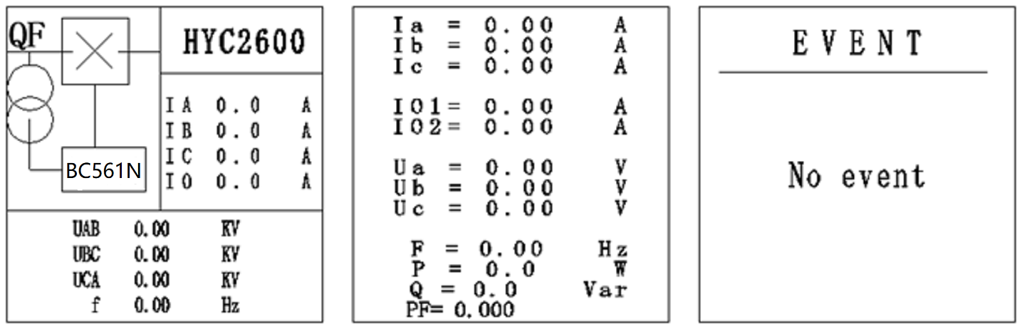
Run the screen Monitor the screen Event log
4.5 Manual closing operation
Manual opening, closing operation refers to the relay outlet opening, closing operation.
Proceed as follows:
The local operation indicator "LOCAL" is illuminated when the device receives a signal that can be operated manually. If the device is in the password protection state, will not be able to manually perform operation, the user first "login" operating system. you can press the "hand Open" button or "hand close" button to start the object associated with the sub-relay, this time, the device produce a "pop" crisp sound (device internal relay action), while the screen into "Event record" screen, resulting in "local operation" SOE record (shown in Figure 4.5). At this point, the manual closing operation is successful. Do not do any operation, after 60S time screen will automatically switch to the "main screen" in the "running screen", or press the three "return" key, the screen will be switched to "main screen" in the "running screen."
4.6 User login
BC561 uses a password protection program, the user is not logged on, only observe the screen, and can not modify any parameters of the device. If you want to modify the parameters of the device, you must first log in to the user, enter the correct password to enter, only after the login is successful, the device can modify the appropriate setting parameters. The user login steps are as follows:
In the main screen, press "ENTER" to enter the main menu, select "User Login" by "Up" and "Down" (Figure 4.6), press "ENTER" to enter the menu, "User Login" has two submenus, "login" and "logout".
In the "User Login" menu, press "ENTER" to enter the login menu by selecting "Login" from "Up" and "Down". "Down", "down" key to modify the number, "left", "right" key to move the cursor, enter the correct input password, then press "ENTER" key, the screen switch to Figure 4.8. Select "Yes", press "ENTER" key to confirm the login, select "No", then press "ENTER" key will cancel the login, the screen to the main menu. The user can determine whether the login is successful by observing the lock icon in the upper right corner of the screen. The icon indicates that the device is not unlocked and the user login fails. The icon indicates unlock and the user logs in successfully. When the password input input error, the screen displays "password wrong! Please return" the words, press "ESC" key to switch to the "main menu" screen. Or do not do any operation, wait 60 seconds, the screen automatically switch to the running screen.
Information: BC561 password decryption, if no 60 seconds without any password protection will take effect again. The factory initial password is: 000000

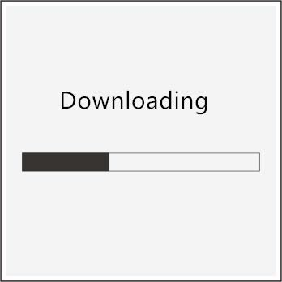
4.7 Download data
BC561 device parameters, settings and other data can be set by two means, one is through the matching BP-PLP software BC561 device parameters, settings and other data settings,or a button on the panel through the operation of its Set up. Regardless of whether the BC561 is in any menu screen, the BC561 can be used to transfer parameters such as parameters, settings and other data after connecting the computer and BC561.

4.8 main menu
Press "ENTER" key in any main screen to enter the main menu, as shown in Figure 4.10. The main menu screen consists of nine submenus. You can use the up and down keys to move the cursor to select the submenu, and the selected object will be displayed. After selecting the menu, press "ENTER" to enter the submenu. Press "Esc" to return to the previous menu.
Serial number | Submenu | annotation
1 | Para. | set unit Parameters： Including the sampling value, angle value, electrical measurement, the clock and the temperature measurement on the motherboard and other information
2 | SetV | Change setting value： Used to set the current setting group and the setting of the modification device
3 | Debug | Debug tools： Used to for the test of switching output, serial data observation and analog channel waveform display
4 | Comm. | Set communication
5 | Clock | Set clock
6 | Info. | Show information：Browse the machine information
4.3 Main menu list
4.8.1 set unit Parameters
In the main menu, select the " Para." The menu is a total of four submenus, The user can move the cursor through the "Up" and "Down" keys, then press the "ENTER" key to enter the selected submenu to modify the parameters.
Parameters need to check the password, modify the password protection, the user must log on to be successful before the change. There are two ways to modify the parameters: one for the bitwise modification, through the "left", "right" key to move the cursor, "up", "down" key to modify the cursor to achieve the value; the other for the whole The parameters are incremented by the minimum step size.
The procedure for setting system parameters is as follows:
Press "ENTER" to enter the "System parameter" option, then press "ENTER" key to enter the menu, then press "ENTER" key, the cursor moves to the parameter after the equal sign , And then through the "up", "down" to be modified. After the modification is complete, press "ENTER" again, the cursor will move to the parameter name, then press "ESC" to exit, the screen will switch to "OK" screen. Press "ENTER" to select "Yes", press "ENTER" to save the previous modification and exit to the "Parameter Setting" screen. If you select "No", the device will not save the " Settings "screen, select" Cancel ", the device will not save back to the" System Parameters "screen.
Para.
Submenu | Measurement data
Language selection | BC561 screen display there are two, one for the Chinese, one for the English.
Analog configuration | "Analog ACConfig" is selected for analog definition (AC connection mode) in 5 ways. When "Analog ACConfig" is equal to "1" or "4", it is suitable for feeder protection. Therefore, "Vs config" Only select "Analog ACConfig","1" or "4".
Power calculation method | "Current config" is 2 or 3 indicates whether the current component used for protection is a two-element or a three-element.
Protection current components | "Current config" is 2 or 3 indicates whether the current component used for protection is a two-element or a three-element.

Information: The connection parameters must be set in accordance with the actual wiring of the site, otherwise you will get some wrong results. Changing the AC connection The wiring parameters must be carried out under all protection and the device can be re-energized for protection.
4.8.2 Change setting value
In the main menu, select the "protection settings" option, press the "ENTER" key to enter the sub-menu, BC561 device can set a total of four different sets of protection settings, the user can replace the "current valuation area" Value group, convenient and quick. The rating group and all settings are password protected. If you want to modify the settings, you must log in to the user before decrypting them.
4.8.2.1 The setting of the current setting group
After the user logs in successfully, select the "Protect Settings" menu in the main menu and press "ENTER" to enter the submenu. Press the "Up" and "Down" keys to move the cursor to the "Current setting area" and press "ENTER" to enter. At this time, press "ENTER" key to confirm the current setting group, and then use the "up" and "down" key to select the desired value group option, select the set value group, press "ENTER" key to exit the modification (the cursor black backlight area is enlarged to indicate that the modification has been made). At this time, press "ESC" key again, the screen will switch to the saved screen as shown in Figure 4.15, select the next step by "left" and "right", then press "ENTER" to confirm whether to save, The screen will jump to the previous menu; select "Cancel", the device will cancel the changes made just, the screen back to the "current rating area" screen.
4.8.2.2 Set value
After the user logs in successfully, select the "Protect Settings" menu in the main menu and press "ENTER" to enter the submenu. Press "ENTER" and "Down" to select the setting group to be set. Press "ENTER" to enter the set value. And then through the "up", "down" key to select the need to modify the value of the selected items will be displayed in reverse, and then press the "ENTER" key to enter the submenu of the selected item.
To "composite voltage" as an example, its parameters to modify. After entering the "Composite Voltage" menu, select the setting value item to be set by "Up" and "Down" key, then press "ENTER" to confirm the setting and change the cursor to "=". If the value of the control word type parameters, only "0" and "1" two states, you can use the up and down keys to modify; set value if the current, voltage, time and other types of parameters, for bitwise modification, can be used Move the cursor to the "Left", "Right" key, and then press "ENTER" to return to the value name.
After all the parameters in the menu have been modified, press "ESC" to exit the modification and the screen will switch to the "Confirm" screen. Select "Yes" from the "Left" and "Right" keys to select "Next", press "ENTER" to confirm the save and the screen will switch to the "Set Group" menu screen (Figure 4.16) The setting is successful (can be viewed in the event log menu). Select "No", then press "ENTER" key, the screen will not save to the previous menu. Select "Cancel", then press "ENTER" key, the device will cancel the parameters just modified, the screen back to the selected value of the menu screen. If you do not do any operation under the "Confirm" menu, the device will not save and automatically cancel all the operations that have just been performed for 60 seconds. The screen will switch to the "Run Screen" in the main screen and be automatically locked.

4.8.3 Debug tools
In the main menu, select "open out" submenu, press "ENTER" key to enter the submenu. The menu contains the "switch input input" and "switch output" submenu options, the cursor position will be displayed at the end, then press "ENTER" key, the screen will jump to the next sub-menu of the selected item, the All the contents of the menu can only be viewed and can not be modified. Through the window can be directly observed the current device into the switching output/input state, intuitive response to the current device working conditions.
Switching Input/output status list
Switching Input/output
Menu item | contect | status
Switch input | DI01～DI10 real-time status | 0 or 1 (0 for no signal input, 1 for signal input)
Switch output | DO01 ~ DO7 real-time status | 0 or 1 (0 for no signal output, 1 for signal output)

4.8.4 Communication settings

Communication settings
Submenu | name | range
mailing address | Local communication address | 1～254
Serial port 1 | Communication rate | 1200、2400、4800、9600、19200、38400
Serial port 1 | Communication protocol | SHELL,MODBUS,IEC-103,DN3.0
Serial port 1 | Parity | EVEN,ODD,NONE
4.8.5 Set clock
表4.10通讯设置
The time setting of the device can be set by pressing the buttons on the panel, or by supporting the BP-PLP software. For manual operation, using the left and right keys to move the cursor, up and down keys to modify the number. After editing, press "ENTER" to save the current setting, press "ESC" key to return to the previous menu.
4.8.6 Show information
In the main menu, select the "device information" option, the menu display content: the machine model, version number, serial number, BC561 serial number serial number of a total of 11 digits or letters, the device for authentication.

The "self-check information" menu includes items such ascontrol word verification, calibration check, logic check, picture data, setting, ferroelectric memory, FLASH memory, clock detection, RAM memory, logic length, logic data The When the device item self-check message is correct, the "√" character is displayed in the status bar.

5 Protection and control functions
5.1 Running instructions
When the device is powered on, the self-test is correct, the normal start condition is met and the run indicator is activated. The logic diagram is as follows:
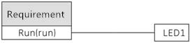
5.2 Remote opening
Logic for controlling the opening of the relay
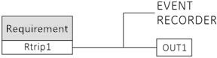
5.3 Remote closing
Logic for controlling the closing of the relay:
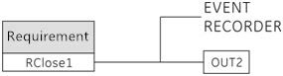
5.4 Distant location
The logic of the switching input signal for remote operation:
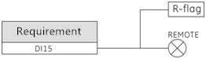
5.5 Local place
The logic of the switching input signal for in-place operation:
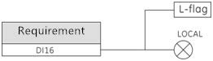

5.6 The low-voltage detection
The low-voltage detection element is used as an intermediate variable and can also be used as a logic condition (FLAG15 low-voltage start flag). By detecting the input input A / B / C three-phase line voltage or phase voltage, the set value You can start low-voltage detection components. The logic diagram is as follows:
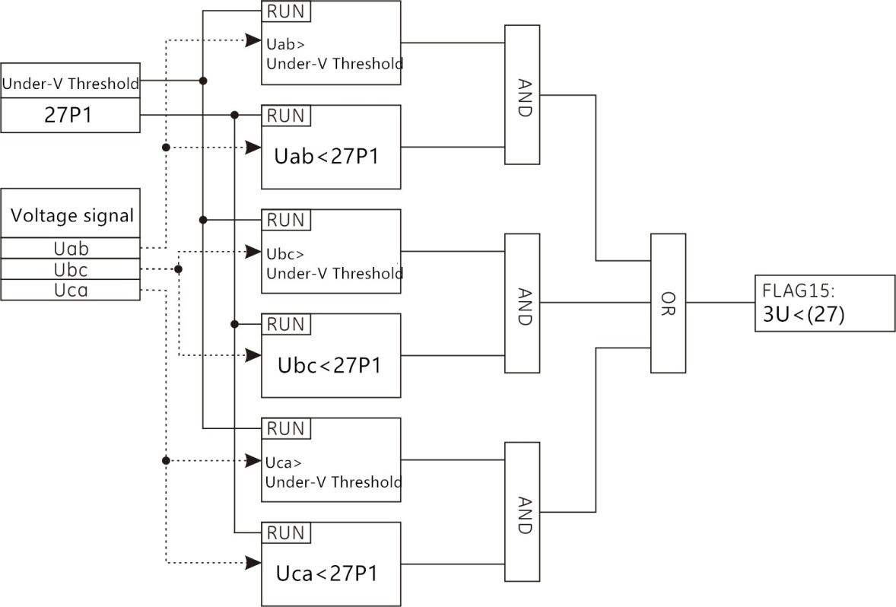
5.7 he voltage-free detection
The voltage-free detection element is used as an intermediate variable and can also be used as a logic condition (FLAG16 without voltage flag). By detecting the input input A / B / C three-phase line voltage or phase voltage, the set value Condition to start the pressureless detection element. The logic diagram is as follows:
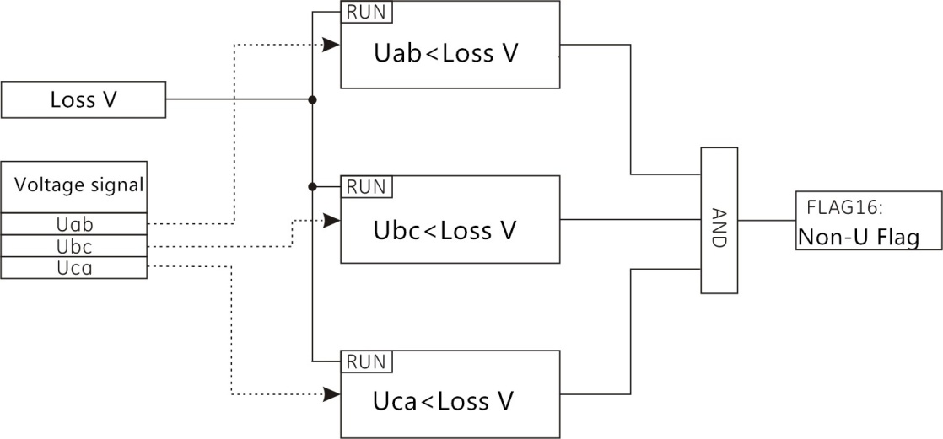

5.8 The non-current detection
The non-current detection element is used as an intermediate variable and can also be used as a logic condition (FLAG17 without flag of non-current). By detecting the input input A / B / C three phase phase current, the set value can be set Start the non-current detection element. The logic diagram is as follows:
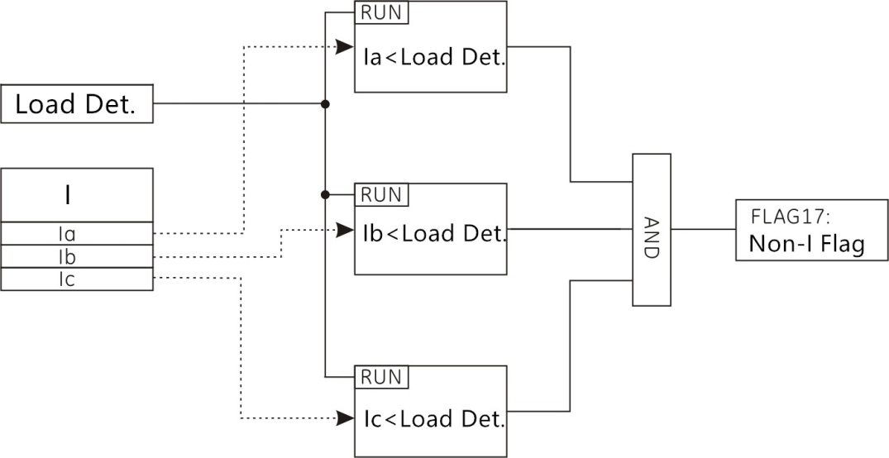

5.9 Fixed-time over-current section (with directional components, re-pressure lockout)
In order to overcome the overcurrent protection in the vicinity of the power supply protection device operating time is long, the use of increased setting value to limit the scope of action, so there is no need to increase the time limit can be instantaneous action (delay component time setting is set to "0") or set A very short time, the action is to avoid the maximum operating mode under the short circuit current to consider, the definite time overcurrent part of the current protection transient transcendence, the shorter the action time, the use of high-value short-circuit protection, the typical protection The range should be less than 80% of the total length of the line at maximum operation. It can be combined with the setting of the positive / negative component latching function and the reset function. The protection logic diagram is as follows.
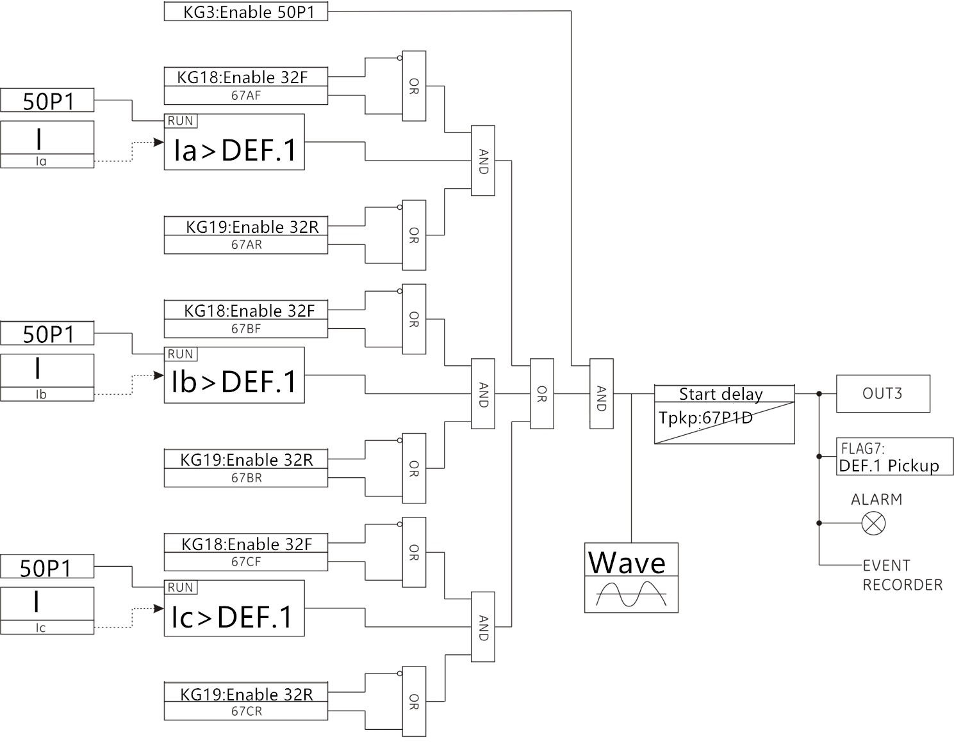

5.10 Fixed time overcurrent two (with directional components, re-pressure lockout)
The protection principle of the two-stage overcurrent two-stage protection is the same as the protection principle of the period-over-current section. The protection logic diagram of the positive / negative direction element locking function and the reset voltage lock function are as follows.
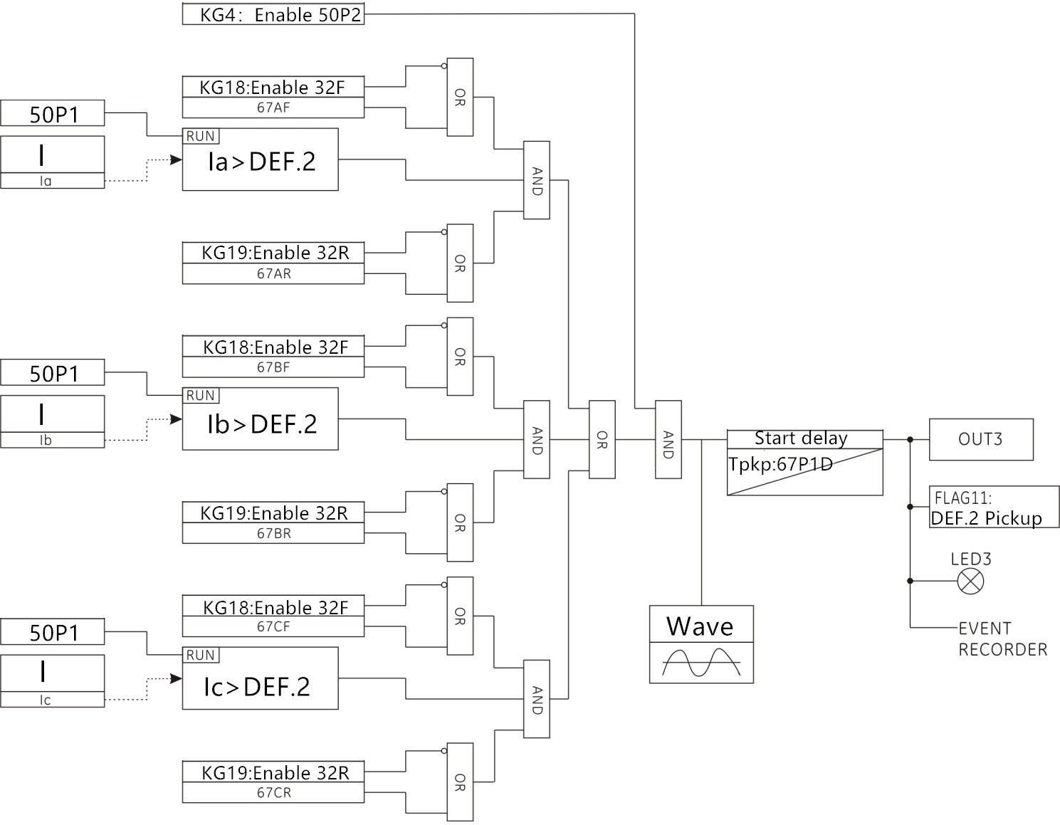

5.11 Fixed-time overcurrent three sections (with directional components, re-pressure lockout)
The protection principle of the three-stage overcurrent overcurrent is the same as the protection principle of the two-stage overcurrent, and the protection logic is as follows.
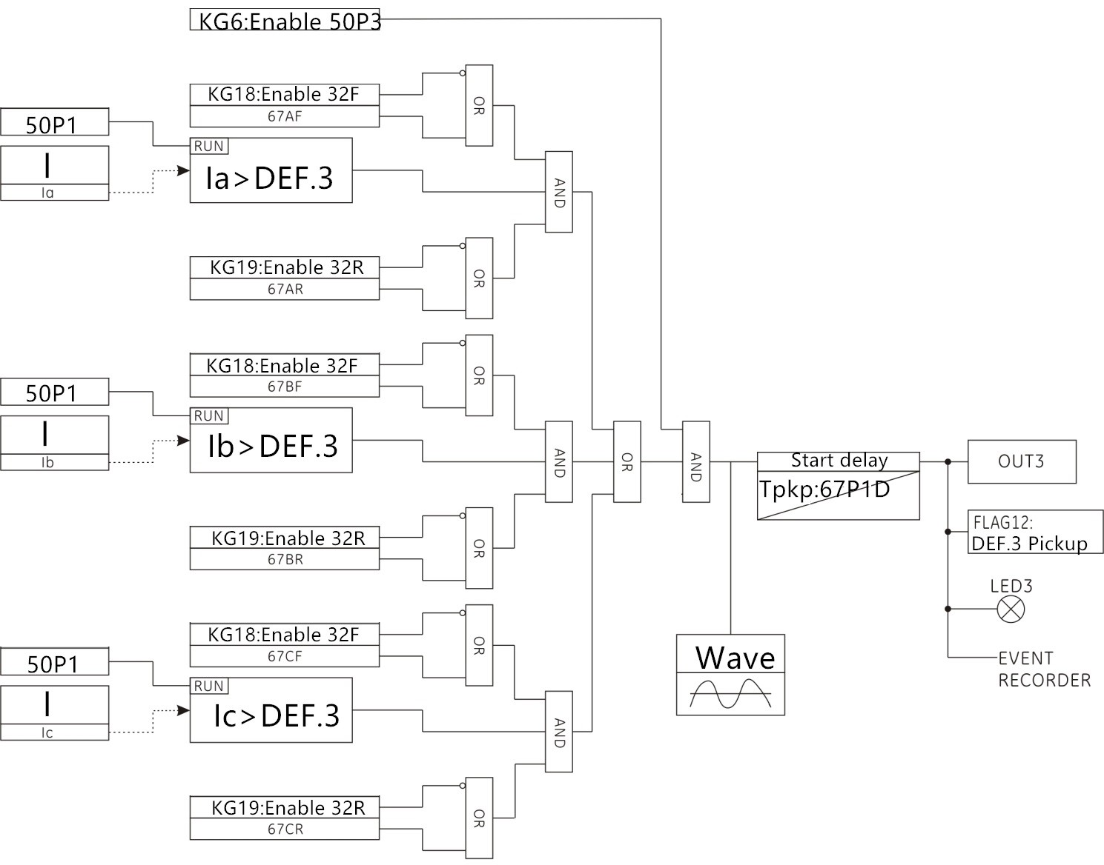

5.12 Zero sequence overcurrent (with directional components)
The zero-sequence overcurrent protection current is taken to the zero sequence current of the zero sequence channel IN, and the positive / reverse direction overcurrent function is selected. When the detected IN current value is greater than the set IN overcurrent setting, the IN overcurrent Component start, the time delay, send a signal. The protection logic diagram is as follows:
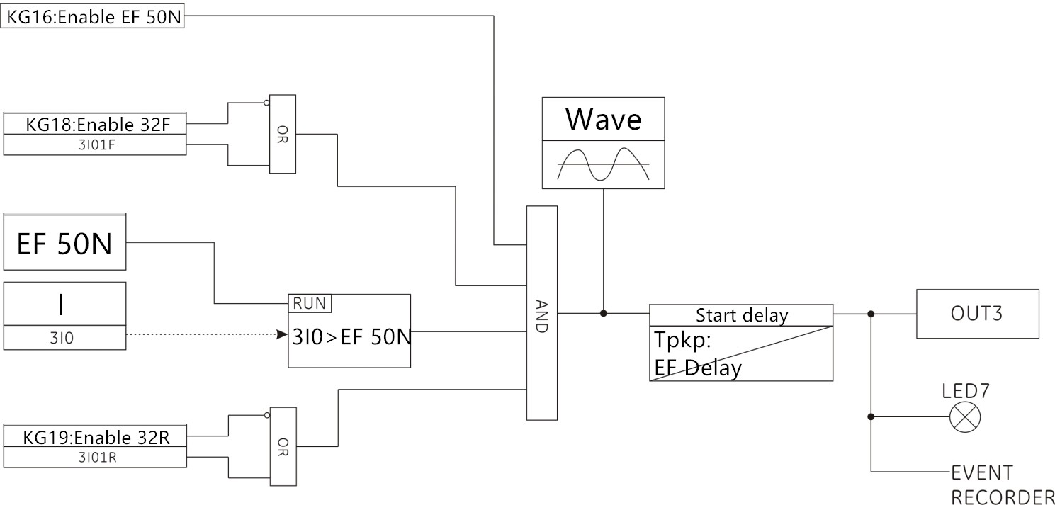

5.13 Grounding overcurrent (with directional element)
Ground I / O protection As with the zero sequence overcurrent protection principle, the analog I01 and IO2 channels on the BC561 are grounded channels, where the I02 channel is the sensitive ground channel, the I01 Grounding overcurrent element can be oriented, the I02 sensitive grounding is a non-directional over- current element. When the detected current is greater than the set grounding current setting, the overcurrent overcurrent protection element is activated, after the start delay, send a signal. The grounded overcurrent element can also be used as an intermediate variable, and FLAG33: Grounding overcurrent action flag. The protection logic diagram is as follows:
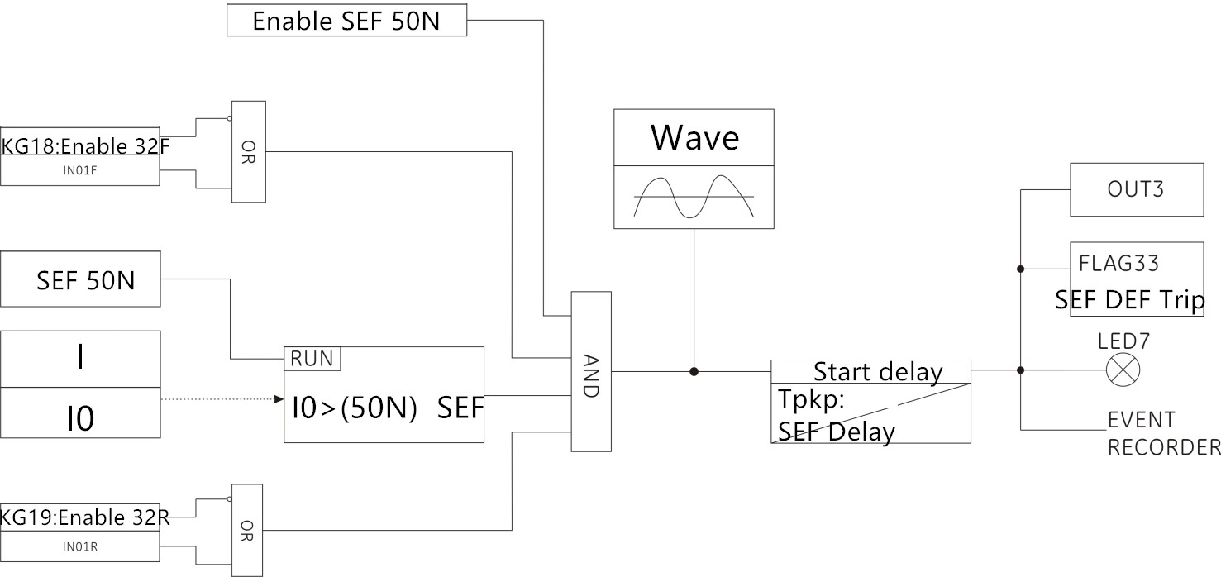

5.14 Inverse time limit overcurrent
Anti-time components reflect four international standards of time / current curve, respectively, the general inverse time, strong anti-time limit, super inverse time, long inverse time. The Inverse time limit component consists of the current input amount, the set current value, the characteristic curve setting value, the times of Inverse time limit time, and the binary output amount.
The relationship between time and current is according to IEC-255 and BS-142, which can be expressed as follows:
$$t_{(s)}=\frac{K\text{.}β}{{\left(\frac{I}{\text{Ie}}\right)}^{α}−1}$$
Where t (s): action time
K: Inverse time limit constant
I: current input amount
Ie: reverse time rated current
The values of the constant α, β are as follows:
Curve | Time / current curve group | α | β
IEC Curve A | General inverse time limit | 0.02 | 0.14
IEC Curve B | Strong anti-time limit | 1.0 | 13.5
IEC Curve C | Super inverse time limit | 2.0 | 80.0
IEC Long Inverse | Long inverse time limit | 1.0 | 120.0
5.1 Inverse time limit parameter value
Standard BS-142.1966 limit the normal current range of 2 to 20 times the set value, in addition, the components for the general inverse time, strong Inverse time limit or super inverse time limit, when the current exceeds the set value of 1.3 times must start; Time limit, when the current exceeds the set value of 1.1 times will start. The protection logic diagram is as follows:
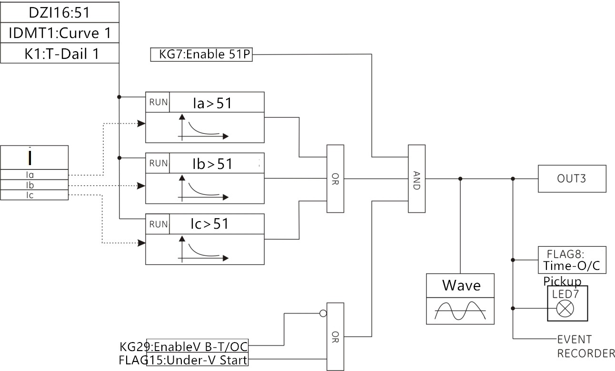
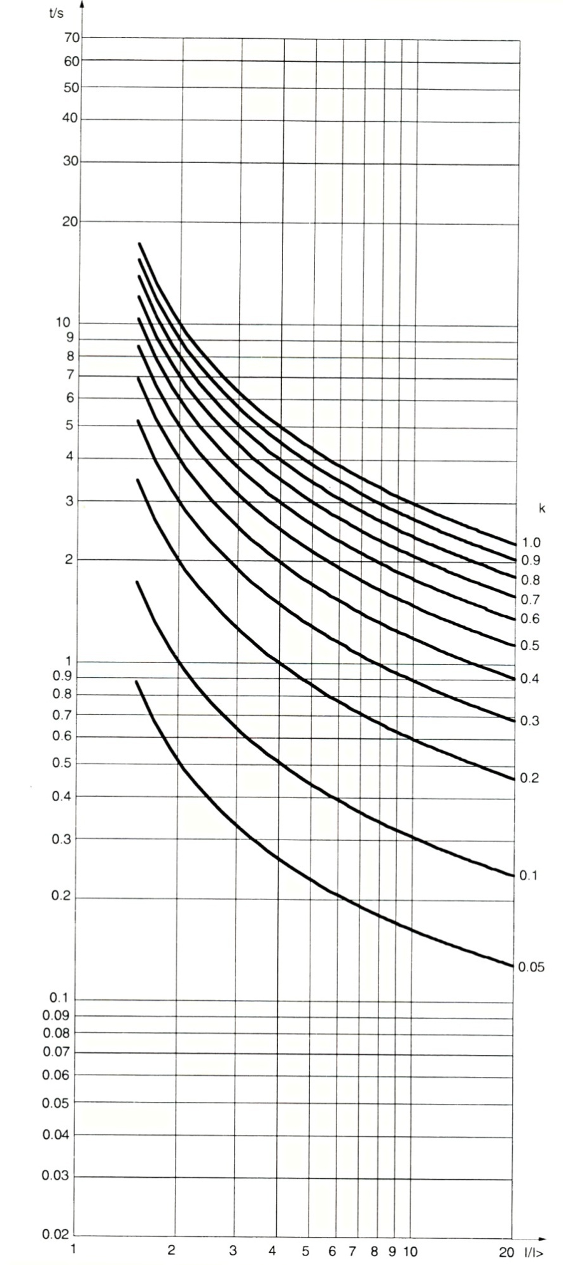
α=0.02 β=0.14
General Inverse time limit curve
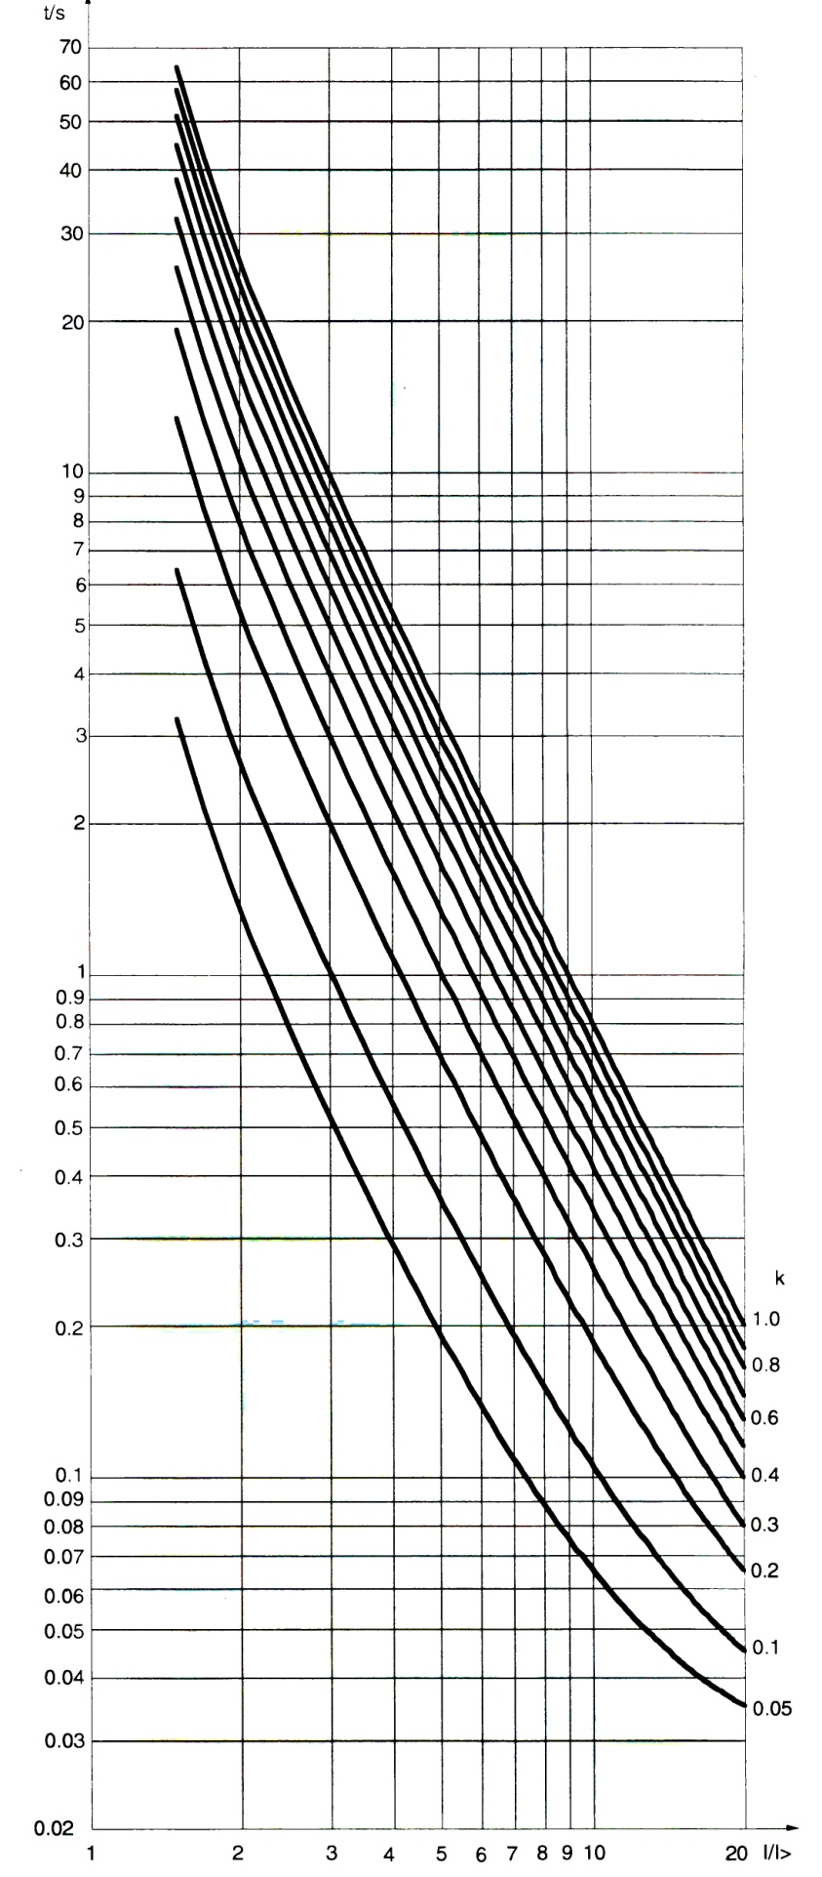
α=2 β=80
Strong Inverse time limit curve
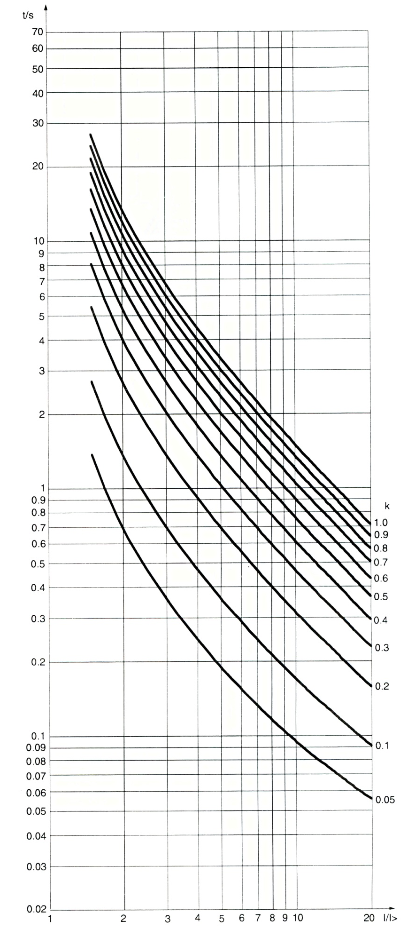
α=1.0 β=13.5
Super Inverse time limit curve
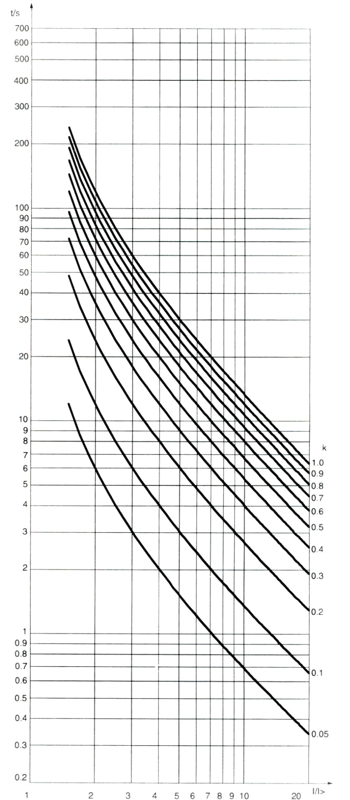
α=1.0 β=120
Long Inverse time limit curve
5.15 Zero sequence Inverse time limit overcurrent
Zero sequence Inverse time limit overcurrent protection principle and anti-time overcurrent protection principle, when the calculated IN current is greater than the set value, through the Inverse time limit component, the signal, the protection logic as follows:
$$I_{N}=i_{A}+i_{B}+i_{C}$$
$i_{A}、i_{B}、i_{C}$： For the sine power frequency current sampling value (obtained after filtering)
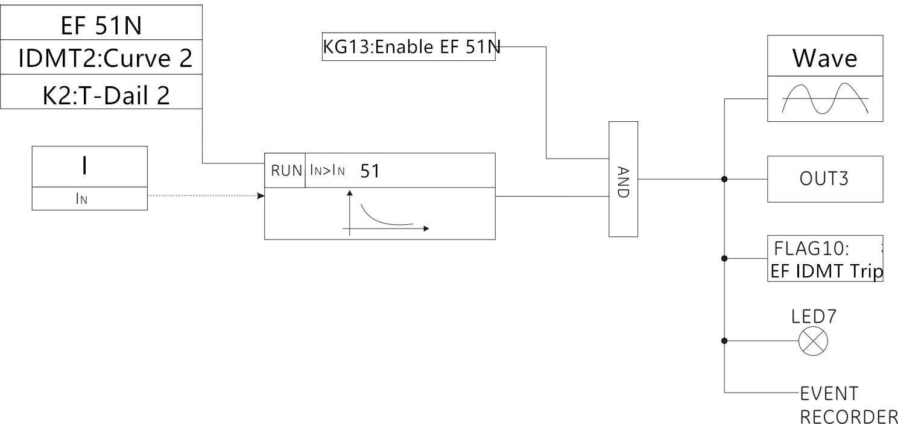
5.16 Grounded reverse time limit overcurrent
The principle of grounding Inverse time limit overcurrent protection is the same as the zero sequence Inverse time limit overcurrent protection principle. When the grounding current IG of the grounding channel is detected to be greater than the set grounding reverse time limit, the Inverse time limit component sends a signal whose protection logic As shown below:
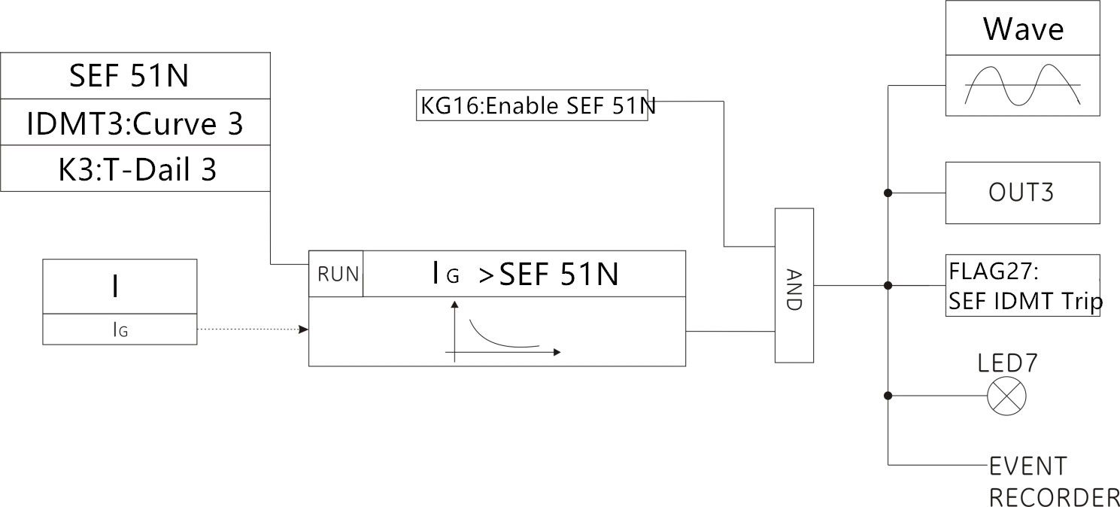

5.17 Negative sequence overcurrent
For the ideal power system, because the three-phase symmetry, so the value of negative sequence components are zero (that is, we often say that the normal state only positive sequence component of the reasons). When the system fails, the three phases become asymmetric, then you can break down the amplitude of the negative sequence components. The same positive sequence current and negative sequence current in the motor generated by the heat is not the same, negative sequence current generated by the double frequency excitation current for the rotor thermal effect is very significant. For the small negative current caused by mild unbalanced supply voltage, overheat protection has been provided for protection, but for severe unbalance, such as stator windings are disconnected or phase sequence reversed, special fast protection must be provided , Otherwise the sharp increase in the negative sequence current will make the motor burned due to overheating. The negative sequence overcurrent protection of the device is mainly for the motor phase, reverse phase, turn short circuit and more serious asymmetrical fault. When the device detects the negative sequence current is greater than the set negative sequence overcurrent value, you can start the negative sequence overcurrent components, and then after the start delay, send a signal. Its protection logic as shown below:
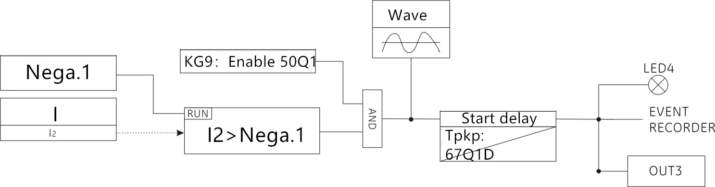

5.18 phase overvoltage
Power system voltage is too high a great harm, may burn out electrical equipment and even paralyzed the system. In order to avoid the high voltage caused by the harm, the use of phase over voltage protection components. When the device detects that any phase voltage is greater than the set over-voltage setting, the phase overvoltage protection element is activated and the signal is issued after the start-up delay. The protection logic diagram is as follows:
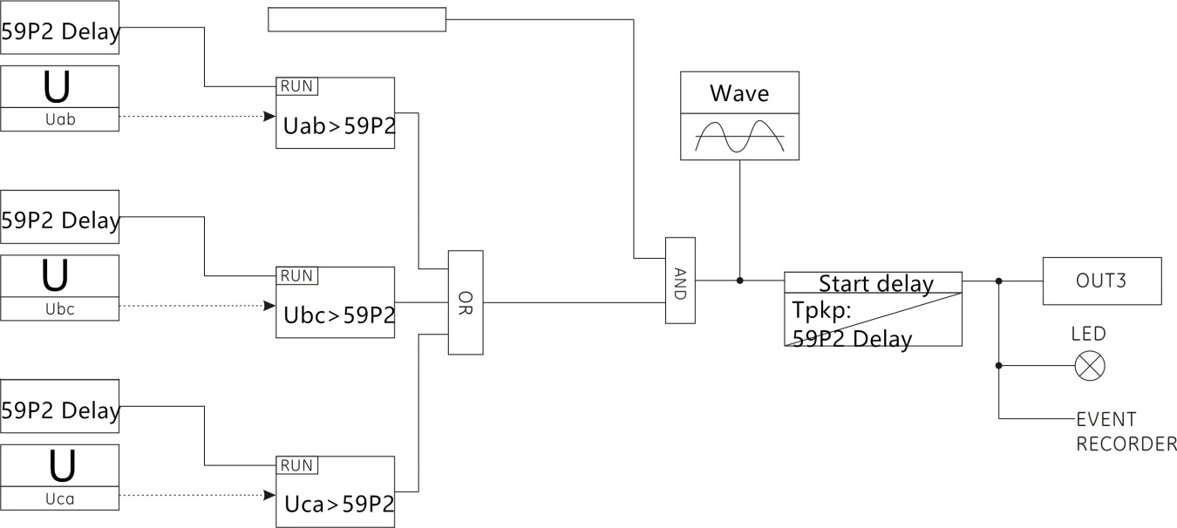

5.19 Phase undervoltage
In the event of a power system failure or abnormality, a low voltage may be generated. This protection can be used to disconnect the circuit breaker in the event of a power system power failure to prepare for system recovery or long backup protection as a primary protection. Its protection logic as shown below:
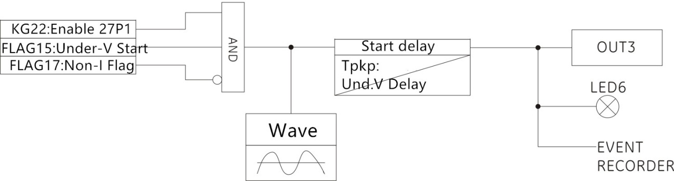

5.20 Zero sequence overvoltage
Zero sequence over-voltage protection principle and phase over-voltage protection principle, to calculate the 3U0 zero sequence voltage as a criterion. When the device detects that the zero sequence voltage is greater than the set zero sequence overvoltage setting, the zero sequence overvoltage protection element is activated and the signal is issued after the start delay. The protection logic diagram is as follows:
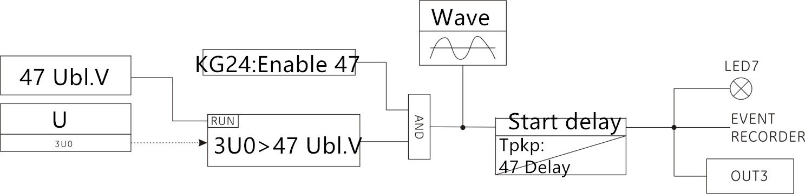

5.21 Over frequency protection
When the device detects the frequency is higher than the set over frequency setting, the over-frequency protection device starts, after the start delay, send a signal. The protection logic diagram is as follows:
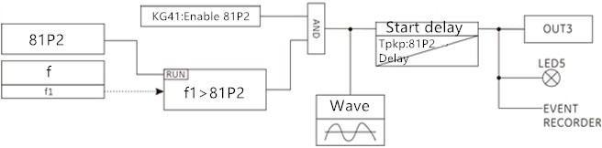

5.22 Frequency change rate (low frequency)
Frequency change rate protection element is a special monitoring system frequency protection components, when the voltage is greater than the set value, the current is greater than the set value, the system load is too heavy, the frequency down. Decrease the speed (slip) is less than the set value, when the frequency dropped to the set value when the export action, cast a low cycle to protect the pressure switch outlet switch will be jumped, get rid of part of the system load to ensure the normal operation of the system. Frequency change rate protection element can choose slip lock / no current lock / no pressure lock function, the protection logic diagram as shown below:
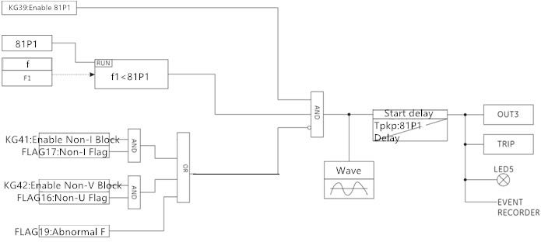

5.24 Trip loop monitoring
Trip circuit monitoring constant components to DI01 and DI02 as input input signal as a criterion, when the two input input only one signal, it is determined that the loop abnormal situation, the control loop abnormal components start, after the start delay issued Signal; when the input input side at the same time have a signal or no signal input input, then determine the loop did not happen abnormal situation.
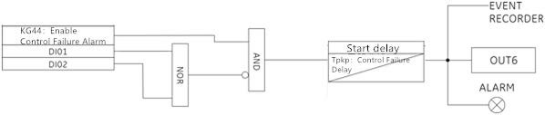

5.25Reclosing conditions
The reclosing conditional element is used for reclosing protection, including the FLAG1 start reclosing flag, the FLAG4 latching reclosing flag, and the FLAG3 complete return sign. The logic is as follows:
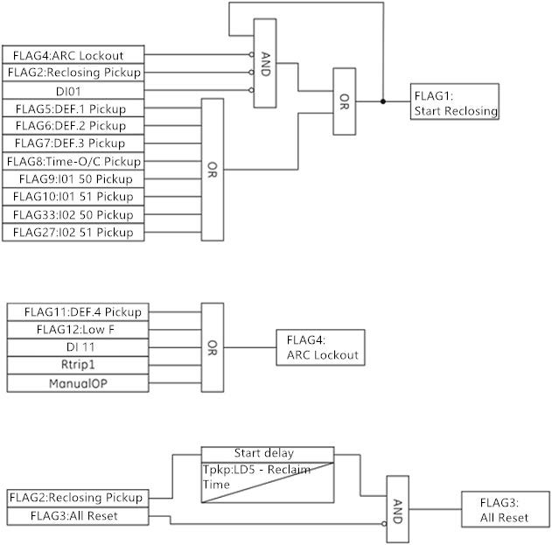
5.26 Three-phase reclosing
The reclosing element is used for reclosing control and can be set to not correspond to reclosing and to protect the reclosing. Automatic reclosing can be set repeatedly reclosing, the factory set up for the three-phase reclosing, can provide a single circuit breaker or multi-circuit breaker fast / slow reclosing. The following figure shows a three-phase reclosing logic diagram:
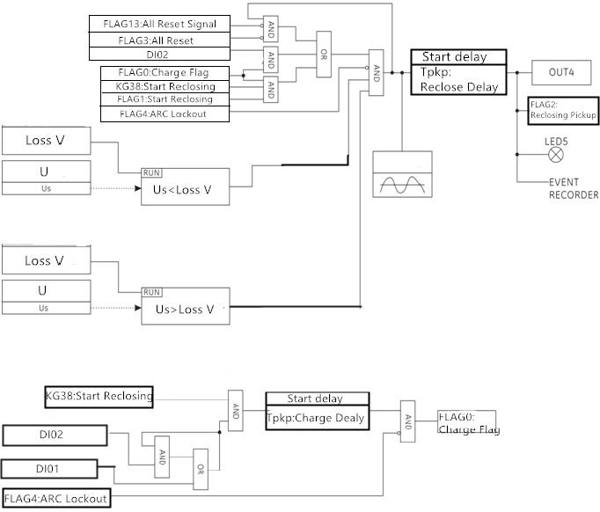

5.27 VT line disconnected
VT substation accident occurred in the substation, is a common fault. Once the VT disconnection is lost, the amount of voltage in the protection device is deviated, and the correct acquisition of the voltage is a prerequisite for distance protection, directional blocking, and overcurrent protection with low-voltage start-up components. The criterion is that when the device detects the current without pressure, and can start the VT broken element; or when the detection of VT broken line negative sequence voltage is greater than the set value, while detecting any phase voltage is lower than the low voltage When setting, you can also start VT broken components, the protection logic as shown below:
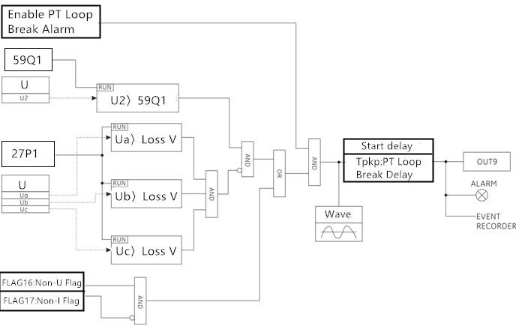

6 Debugging test
6.1 Visual inspection
Make sure that the BC561 is not damaged during transport and that all screws are properly fastened and that all relay terminals are in good condition.
Make sure that the information displayed on the relay panel matches the data displayed on the display and conforms to the required relay model.

6.2 General considerations for power networks
All devices that use AC current are affected by frequency. Since a non-sinusoidal waveform consists of a fundamental wave plus a series of harmonics from this fundamental, it can be concluded that the device using AC current is affected by the waveform used. To correctly test the use of alternating current relays, it is important to use a current and / or voltage sine waveform. Can not clearly represent the sine wave (no harmonic) purity of a particular relay. However, any relays that contain the sintonized loop [R-L) and R-C (resistance-capacitance) circuits will be affected by non-sine waves, as is the case with BC561. For most AC current and voltage tables, these relays respond in different ways to voltage waveforms. If the power supply network used for the test contains a wide range of harmonics, the voltmeter and relay response will be different. The relay has been calibrated at the factory with a network with the least harmonic component 50 or 60 Hz. When testing a relay, you must use a power supply network with no harmonics in its waveform. The ammeter and timer for testing relay operating and operating times must be verified and their accuracy is higher than the accuracy of the relay. The test power supply must remain stable, mainly because the value of the power supply is close to the operating threshold. It is important to note that the accuracy of the test depends on the grid and instrument used. Performing functional tests with inappropriate power networks and meters is useful for checking if the relay is working properly. Thus, the operating characteristics of the relay can be confirmed in an approximate manner. However, if these conditions are used to verify the relay, the operating characteristics will exceed the allowable range. The following sections demonstrate in detail the test of confirming the full functionality of the relay.

6.3 Power on self test
6.3.1 LED inspection
After the device is powered on, the LED can be lit automatically. After the self test is finished, if the device is working normally, the running indicator (RUN) works with the pulse attribute.

6.3.2 LCD
After power on the LCD will be bright screen display, check whether there is a blind spot, the display of data, images, text, etc. is complete.
6.3.3 Device abnormal self-test relay (ALARM)
Device is also starting the clock, set value, logic data, power supply voltage, flash memory, machine temperature and other content self-test. If all the self-test items are correct, BC561 alarm relay start, issued a "pop" sound, normally closed contact open. If the device self-test error, the relay will not turn on the electric shock, latch all fault output.

6.4 Key detection
After the device is powered on, each button can be flexible and reliable operation, and can make the right response.

6.5 Screen display and switch detection
6.5.1 Screen display
The contents of each screen and the menu name should correspond to each other, no typos, each parameter and its description can correspond, and no spelling mistakes. Icons, single-line charts, etc. to be true.
6.5.2 Screen switch
Each screen can be switched through the up and down left and right keys, through the "ENTER" key to enter the next level menu, through the "ESC" key to return to the previous menu; the same screen parameters can be selected by the up and down keys;
6.5.3 Switch in English and Chinese
By setting the parameters to switch between Chinese and English display, before and after switching the various screens and their menus, parameters, description are correct.

6.6 Parameter setting and save detection
Press the BC561 parameter to modify the steps to modify the parameters, save the data into effect. After the saved data should remain after power-down; set value group can switch, switch after the four sets of values can be independent and save, but only the current investment group can work.

6.7 Clock detection
After the device is powered on, it can set the time manually by pressing the key on the panel or after the connection with the software. The clock travel time should be correct and the saved time can be saved.

6.8 SOE detection
The change of the switching input status, the change of the setting value, the generation of the protection action and the operation of the device, power failure, panel reset and other operations should produce the corresponding SOE, and should have the correct time scale, SOE code, SOE name, code And the name should be corresponding to protect the fault of the SOE should also have the corresponding fault action value; SOE is always the first preservation of the latest, recorded over 100 followed by the last one.

6.9 Communication detection
Verify that the available communication ports allow the device to communicate.
The ports to check are as follows:
Front: USB port
Back: RS485, RJ45 - Ethernet.
You must use a computer with a BC561 PLP Setup software and an appropriate connector.

6.10 Measurement detection
BC561 related parameters are set as follows:
Serial number | Parameter Name | Set the value | range
1 | Analog ACConfig | 1 | 1～5
2 | Power config | 2 / 3 | 2 / 3
3 | Current config | 2 / 3 | 2 / 3
4 | Vs config | 1 | 1～3
5 | CT ratio | 100 | 0～9999
6 | VT ratio | 100 | 0～2200
7 | CT rating | 1 | 1 / 5
8 | I01 ranBAIYUE ELECTRIC | 100 | 0～9999
9 | I02 ranBAIYUE ELECTRIC | 100 | 0～9999

Information: The part of the parameter is not the same as the model of the selection device. The configuration is different. The parameters are slightly different. Please refer to the actual parameters.

6.11 Contact input and Output detection
6.11.1 Contact input test
In the binary input input port threshold voltage of 24VDC power supply, the switching input should change from 0 to 1, and produce the corresponding SOE, remove the voltage, will produce 1 to 0 state changes, and produce Corresponding SOE.
6.11.2 Output test
After successful login, enter the "Test of switching output " menu, select the related switching output channel, and in the switching output loop connected with a small light or multimeter, press the "ENTER" key to test the operation, the specific test steps please refer to 4.8.3 The status of the channel from 0 to 1, the small light is lit up or the multimeter is tweeted, then press the "ENTER" key, the channel status is from 1 to 0, the small light is off or the multimeter stops the call; the "ALARM" exit is the device abnormal relay Node, the device is powered off, the outlet node is closed, the device is started successfully, the node is disconnected.

6.12 Fault recorder detection
Protection of the fault should occur after the corresponding fault recording, the contents should have the correct time scale, the first 4 after the 24 cycles of the current or voltage waveform, value and the switch state, fault record can save a total of 8, Record the last one after the eight in order to cover the last one. You must use a computer with BC561's BP-PLP software and an appropriate connector.

6.13 Power detection
Apply the minimum and maximum voltage to BC561. For each voltage value, to verify that there is a voltage, the alarm relay is energized and exits when it is lost. The device ensures a "device power" event record after each power-up.
Control power rating: 24V DC/AC
Range: 18~36V DC/AC

7 Frequently Asked Questions and Handling
If there is a problem finding the equipment, we strongly recommend that you follow the recommendations below before sending the equipment back to the factory. Although it can not solve all the problems, at least they will make you as soon as possible to determine the problem in order to repair as soon as possible.
If you need to return the equipment to the factory for repair, please use the appropriate Return Material Authorisation procedure and follow the shipping instructions provided by our service department, especially when international shipping. This can solve the problem quickly and effectively.
classification | problem | possible reason | Processing recommendations
protection | The relay does not trip | This feature is disabled  Not put in  Conditional lockout | Check that the self-check information is correct  Put the corresponding protection control word  Check if the latching condition is met
general | After the BC561 is powered up, the panel indicator is not lit. | The supply voltage is not enough  Fuse tube fuse  Not equipped with insurance tube  Wrong wiring | Check the supply voltage  Replace the new T 3A fuse  Fitted with T 3A fuse  Check the auxiliary power supply terminal number
general | After supplying the BC561, the display clock is very different from the actual one | Time operation is set incorrectly  Invalid battery in the device | Reset the time  Replace the new 3V button battery
Communication | BP-PLP and BC561 panel USB port can not communicate | Wrong communication cable  The communication cable is damaged  BC561 or PC is not grounded  PC's USB port is damaged | With the manufacturers to provide special cables  Replace the new communication cable  To ensure that the two reliable grounding (portable PC battery power without grounding)  Make sure the USB port of the PC is good
Communication | BC561 backplane RS485 port can not communicate | PC communication parameters are set incorrectly  Wiring polarity is wrong  BC561 or master is not grounded  Communication parameters or protocols are inconsistent | Check the PC's communication parameter settings  Swap +, - wiring  To ensure that the two reliable grounding  Check the communication parameters and communication protocol settings
Communication | BC561 backplane Ethernet port can not communicate | PC communication parameters are set incorrectly  The cable is damaged  BC561 or master is not grounded  Communication parameters or protocols are inconsistent | Check the PC's communication parameter settings  Replace the new cable  To ensure that the two reliable grounding  Check the communication parameters and communication protocol settings

8 Equipment maintenance
The equipment is maintenance-free for the specified period of time when the BC561 unit is used in the "Technical data" section and the conditions specified in this manual. The BC561 device electronic circuit does not have any components that are subject to abnormal physical or electrical wear.
If the environmental conditions are different from those specified in the "Technical Data" section (eg temperature and humidity), or if the atmosphere surrounding the unit contains chemically active gases or dust, the equipment should be visually inspected in conjunction with a secondary test. The following points:
● mechanical damage to the enclosure and terminals,
● equipment panel or enclosure dust,
● equipment wiring terminals, enclosure or internal corrosion traces,
If the protection terminal is not operating correctly, or if the action value is significantly different from the protection terminal characteristics of the protected equipment, the protection terminal needs to be repaired. Please contact our company or related agents for more information on inspection, overhaul or re-establishment of protective terminals. Due to not work, to BC561 equipment to return to my company for maintenance, please contact with my company. In the maintenance of the transport device on the way, must be carefully packaged to prevent further damage to the equipment.

