**BY360-CD/220 Permanent Magnet Switch Controller**

|  |  |
| --- | --- |
| E:/360MoveData/Users/kejay/Desktop/456456.png456456 | 1. **Overviewwwew**   The controller is specially designed for the purpose of operation of monostable permanent magnet switches. The controller applies advanced electrical and electronic technologies, which suitable for single coil mechanism, It has capacitive voltage detection and undervoltage blocking function. The controller adopts industrial-grade components, industrial-grade design, modular package, anti-vibration, moisture-proof, and high reliability. |

**2、Technical Data**

**参数**

|  |  |  |  |  |
| --- | --- | --- | --- | --- |
| Description | Min | Regular | Max | Conditions for Test |
| Working Voltage (Vdc) | 160 | 220 | 300 |  |
| Opening Current ( A) | 0 | 75 | 125 | 20ms |
| Closing Current ( A) | 0 | 75 | 125 | 40ms |
| Time of Opening（ms） |  | 15 | 99 | Available for Customization |
| Time of Closing（ms） |  | 40 | 99 | Available for Customization |
| Time of Response（ms） | 4 | 5 | 6 | Available for Customization |
| Under Voltage blocking（Vdc） | 100 | 180 | 300 | Adjustable |
| Signal Input Voltage（Vdc） | 18 | 24 | 36 |  |
| Insulation Resistance（MΩ） | 100 |  |  |  |
| Dielectric strength（Vac） |  | 2500 |  |  |
| Ambient Temperature（℃） | -40 | - | +70 |  |
| Storage Temperature（℃） | -45 | - | +85 |  |
| Weight | 540 |  |  |  |

|  |
| --- |
| **3、Introduction of Model** |

**BY360----- Code of product**

**CD----------Single coil mechanism**

**220V-------Rated operation voltage**

**Option：-BS ----- position blocking（Module needs to additionally acquire switch closing signals ）**

|  |
| --- |
| **4、Instructions for Operation** |

1. Wiring

The cables for opening and closing are wires no less than 2.5 square milliliter, and others can be wires of 1.0 square millimeter. Pay attention to the polarity in connection, or it can damage the module.

2）Adjustment of Under Voltage

To prevent operations when the capacitor is under voltage（180V）, the voltage

range of under voltage lockout can be set through potentiometer for adjustment on the panel(side). To avoid improper operations of opening or closing, add an adjustable DC voltage in both “+” and “-” of capacitor, and adjust the DC voltage to the set voltage of potentiometer, to make the indicator light on.

3）Introduction of Warning Relay and Indicator Lamp

Operation Indicator Lamp: Flashes at interval of 1 second at work. Quick flashes for warning or fault.

Voltage Indicator Lamp: On, the operation capacitor is charged for operation; Off, under voltage for the operation capacitor, and operation is not allowed.

Position Indicator Lamp: On, for switch is closed; Off, switch is open.

Warning Relay: Closed, module is at work and available for operations; Open, fault happens to module or capacitor is under voltage.

4） Time of Operation

The default set of module: Time of Closing Operation, 40ms; Time of Opening Operation, 20ms.

The time of operation can be set, please indicate the requirements at purchase.

|  |
| --- |
| **5、External Design and Dimensions for Installation** |

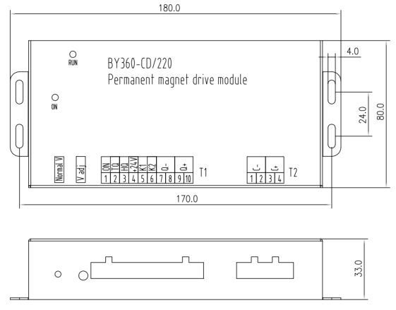

|  |
| --- |
| **6、 Diagram of External Connection** |

|  |  |  |  |  |  |
| --- | --- | --- | --- | --- | --- |
| Terminal No. | Terminal Name | Definition | Terminal No. | Terminal Name | Definition |
| T1-1 | **ON** | Test of Closing | T1-8 | **Q－** | Switching Coil**－** |
| T1-2 | **TQ** | Closing Signal Input | T1-9 | **Q＋** | Switching Coil**＋** |
| T1-3 | **HQ** | Opening Signal Input | T1-10 | **Q＋** | Switching Coil**＋** |
| T1-4 | **+24V** | 24V Output **＋** | T2-1 | **C－** | Capacitor**－** |
| T1-5 | **K1** | Module Fault Signal Output | T2-2 | **C－** | Capacitor**－** |
| T1-6 | **K2** | T2-3 | **C＋** | Capacitor**＋** |
| T1-7 | **Q－** | Switching Coil**－** | T2-4 | **C＋** | Capacitor**＋** |

